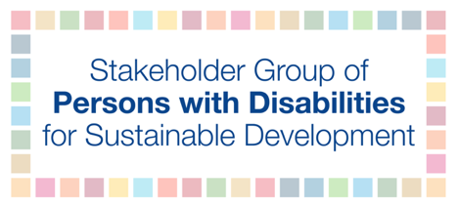

UN Secretary-General Meeting with Civil Society: Financing for Development in the Era of COVID-19 and Beyond

November 2, 2020, 9-11:30 EST

Talking points for Dr. Mohammed Loutfy

Two-minute intervention under the theme of A New Global Economic Consensus to advance the 2030 Agenda

The Stakeholder Group of Persons with Disabilities strongly supports an International Economic Reconstruction and System Reform Summit under the aegis of the United Nations, and for global economic governance reforms that can enable the transition to just and human-rights based economies.

These priorities are particularly pressing for persons with disabilities, for whom the pandemic has sharply deepened pre-existing inequalities.

Persons with disabilities are more likely to live in poverty compared with their peers without disabilities and, owing to structural inequalities linked to attitudinal, environmental and institutional barriers, are less likely to have access to employment, health, education, social protection and other services.

Persons with disabilities are among those most affected by COVID-19. Persons with disabilities are further disadvantaged by the socioeconomic consequences of the pandemic and government responses. Moreover, in the Covid-19 pandemic, some persons with disabilities experience double jeopardy—not only are persons with disabilities disproportionately impacted by the pandemic, but they are also disproportionately excluded from protection and survival support.

There is an urgent need for public resources to tackle both the immediate barriers that persons with disabilities face in accessing support, and also the underlying social inequalities that have left persons with disabilities disproportionately exposed to the effects of COVID-19.

This includes the absence of universal and adequate social protection. While many countries have been developing or reforming their social protection programs and schemes to provide better support to persons with disabilities and their families, the majority remains unprotected and unsupported, especially those in the “missing middle.”

All countries need sufficient fiscal space to tackle these and other challenges: that is why it is so important to hold an International Economic Reconstruction and System Reform Summit, under the aegis of the United Nations, that contributes to systemic reforms of global governance on debt, tax and other critical issues.

We also call for:

- A progressive increase in dedicated public resources to support the full inclusion of persons with disabilities and their families in COVID response and recovery. Domestic resources are fundamental to this, but international cooperation also has a key role to play. If economic reform policies are proposed, non-discrimination against persons with disabilities must be a key criterion in their assessment.
- Transparent reporting of domestic and international resource allocations for the realization of disability rights, and of the extent to which public spending delivers inclusive results for persons with disabilities. All governments and development actors should collect data disaggregated by disability, sex and age to adequately assess the impact of programs and projects on persons with disabilities.
- Providers of official development assistance should also adopt and systematically use the disability marker of the Development Assistance Committee of the Organization for Economic Cooperation and Development to measure and monitor financing for disability inclusion.
- Close consultation and active involvement of persons with disabilities and their representative organizations in all efforts related to international cooperation and the planning, implementation and monitoring of COVID-19 response and recovery efforts are needed.
- Inclusion of persons with disabilities and their representative organizations is more important than ever, not only to address existing inequalities and barriers, but to tackle new and emerging challenges.

Thank you.

ADD International. (2020). COVID-19: Double Jeopardy for Persons with Disabilities.

