(In the order as they appear on the agenda)

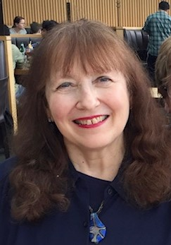
Dr. Ruth Warick is First Vice-President of the International Disability Alliance. She was formerly a Senior Accessibility Advisor at the University of British Columbia where she worked for over 25 years. Currently, she is Director of Programs and Services for Wavefront Centre for Communication Accessibility in British Columbia, Canada. She was born with a hearing loss and was a founder of the national hard of hearing organization in Canada and was president of the International Federation of Hard of Hearing People for over a decade.

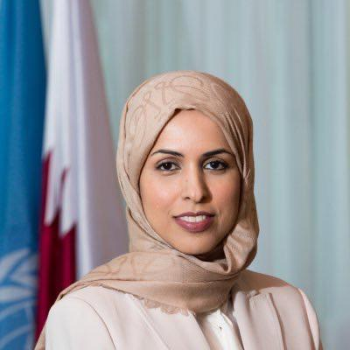
Ambassador Shk. Alya Ahmad Saif Al-Thani is the Permanent Representative of Qatar to the UN in New York. Prior to that Ms. Al-Thani was her country’s Permanent Representative to the United Nations in Geneva before which she served as Ambassador to the Cabinet of the Ministry for Foreign Affairs from August 2011 to October 2011. She was Deputy Permanent Representative at Qatar’s Permanent Mission to the United Nations in New York from May 2010 to July 2011, having previously been Minister Plenipotentiary from June 2009 to April 2010 and Counsellor from April 2007 to May 2009. From September 2006 to March 2007, Ms. Al-Thani was the Director of the Division of the Rights of the Child in the General Secretariat of Qatar’s Supreme Council for Family Affairs, having served as Acting Director between June 2004 and August 2006. From October 2003 to May 2004, she was a Senior Specialist in the General Secretariat of the Supreme Council’s Department of International Relations. Ms. Al-Thani holds a Master of Arts in international studies and diplomacy from the University of London’s School of Oriental and African Studies, and a Bachelor of Science in economics from Qatar University.

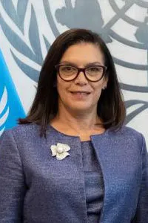
Ambassador Carla Maria Rodriguez Mancia is the Permanent Representative of Guatemala to the United Nations in New York since September 2022. She is the first Guatemalan woman to hold this post. She was until August 2022 the Permanent Representative of Guatemala to the United Nations and other International Organizations in Geneva, Switzerland. She has been serving at the Ministry of Foreign Affairs of the Government of the Republic of Guatemala since February 1990 in various capacities. Before joining the Ministry of Foreign Affairs of the Republic of Guatemala she worked as Programme Assistant at the Guatemala Desk at the UNICEF Area Office for Central America. She holds a Degree on Political and Social Sciences with specialization on Political Sociology from the Rafael Landivar University in Guatemala graduating with honours -Cum Laude- and Best Thesis of the Year Award. She has been distinguished with decorations from the Ministry of Foreign Affairs of the Government of Guatemala, and from the Governments of the Republic of Chile, Federal Republic of Austria and Kingdom of Spain.

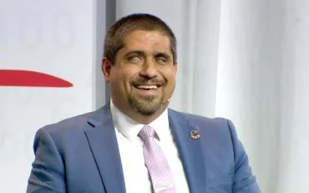
Jose Viera is Director of Advocacy at the International Disability Alliance. Previously, he worked as the Chief Executive Officer of the World Blind Union, where he also worked as Human Rights Policy Advisor prior to being CEO - supporting more than 100 different national associations of the blind in advocacy work to promote inclusive and productive lives of blind people. He has also acted as Permanent Representative of the Stakeholder Group of Persons with Disabilities. Jose has a Master’s degree in Management of Development from Torino University, Italy, and a Bachelor’s Degree in International Relations. For the past 10 years, he has also worked part-time as Associate Professor of the International Relations Department at the Siglo 21 University, in Cordoba Argentina.

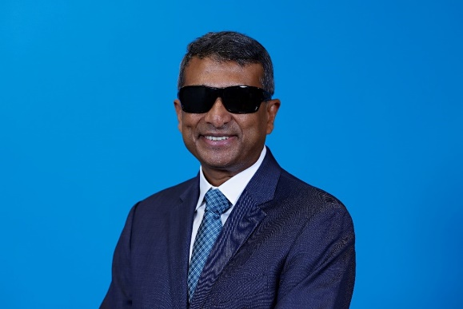
Gopal Mitra is the Global Lead on Disability and Development in Programme Group, New York Headquarters, where he provides strategic and technical leadership to deliver on UNICEF’s global commitments on disability inclusion. Between 2019-2022, Gopal led the Disability Inclusion Team in the Executive Office of the Secretary-General (EOSG) and worked on implementation of the UN Disability Inclusion Strategy (UNDIS). Gopal joined UNICEF’s Disability Section in 2012 and also held various posts at Leonard Cheshire Disability in London and in South Asia. Gopal holds an MA in Social Work from the Tata Institute of Social Sciences in India, and an MSc in Development Management from the London School of Economics (LSE), UK.

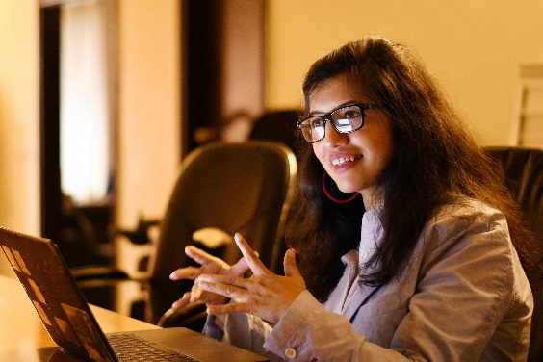
Abia Akram is a disability rights activist from Pakistan, chief executive of the National Forum of Women with Disabilities and founding member of the Special Talent Exchange Program (STEP) and Ageing Disability & Diversity Task Force in Pakistan. She is a trustee for Sightsavers, board member for the Asia Pacific Woman, Law and Development Organization; global chair for the Global Forum on the Leadership of Women and Girls with Disability; and chair of the Asia Pacific Women with Disability Network. She was one of the BBC’s top 100 women of 2021 and is the global ambassador for Sightsavers Equal World ‘Promise in Peril’ campaign.

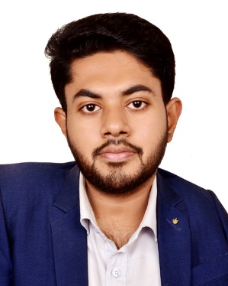
Nayem Molla is a youth disability rights activist based in Dhaka, Bangladesh. He currently works with the International Disability Alliance as an Assistive Technology User Fellow, empowering the assistive technology movement worldwide. Previously, Nayem worked on disability inclusion and democratic governance programs with organizations including CEPPS, IFES, MGR, and PDF. He is a recipient of the Amra Notun Young Changemakers' Award 2023 from BRAC.

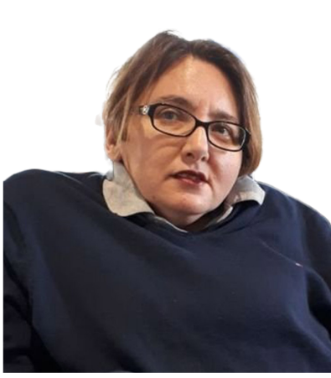
Dr. Ola Abualghaib is Manager of the UNPRPD Technical Secretariat. She led the organization’s development and implementation of the Strategic Operational Framework (SOF) for 2020-2025, which positions the UNPRPD MPTF as a key player in supporting countries advancing disability inclusion. Under her direction, the organization has successfully launched and implemented over 40 joint programmes across all regions. Ola has more than twenty years of experience working on gender and disability in development, including in fragile and crisis-affected settings in the Arab States, Africa and Asia. Before joining UNPRPD, she was the Director for Global Influencing and Research at Leonard Cheshire Disability in London, UK. Ola holds a PhD in Social Protection from the University of East Anglia, UK.

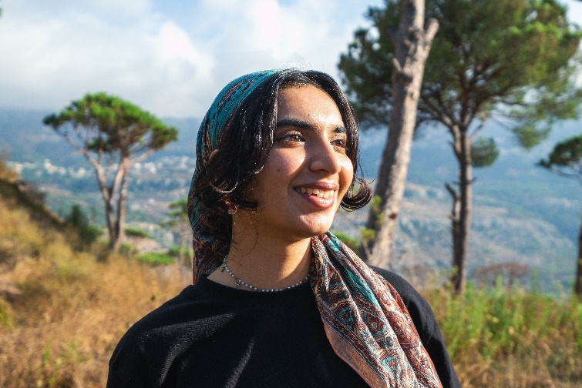
Ayshka Najib is a climate justice activist and organizer based in the UAE. Her work focuses on ensuring the leadership and meaningful participation of those at the frontlines of the crisis and this is reflected in her advocacy with Fridays For Future MAPA (Most Affected People and Areas). Ayshka is one of the UNICEF Youth Advocates to the UAE and also works with the UNICEF MENA regional office in facilitating the Technical Cohort on advancing young women and girls’ leadership on climate change. As Youth Lead for the Action Coalition on Feminist Action for Climate Justice (FACJ), she works with UN Women and the Generation Equality Campaign to push for recognizing the intersectionality of gender equality and climate justice in decision making spaces as well as at the grass roots level. She has co-authored the CSW66 Global Youth Recommendations on Youth, Gender, and Climate as well as actively co-organised the Young Feminist Caucus and the Women’s Rights Caucus. At the age of 18 Ayshka’s work and commitment has been recognised with the Asian Youth Icon Award by Zero Hour Asia.

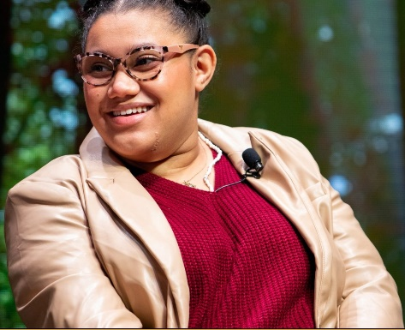
Daphne Frias is a 25-year-old activist. As an unapologetic Latina, she is committed to highlighting the diversity of her community. Daphne has Cerebral Palsy, and uses a wheelchair to ambulate. She is fiercely proud to be a loud champion for persons with disabilities. Active in the fight against gun violence and for voting rights, Daphne has been fighting the climate crisis as well. Her work deconstructs the silos between disability and the climate crisis with a public health approach. She was appointed as spokesperson for the global climate strikes that took place on September 20th, 2019. She was featured as a key panelist at the New York Times Climate hub in a conversation moderated by Emma Watson. Most recently she was appointed to the Natural History Museum’s Generation Hope advisory board where she has helped to highlight the voice of young activists across the museum’s content. She has no intention of backing down until the health of our earth is secure. Her work has been featured in the New York Times, Forbes, Teen Vogue, NPR, Vice, Elle, among many others.

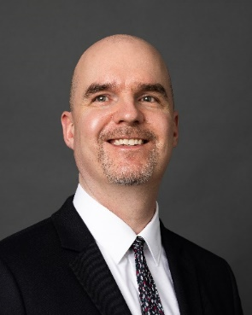
Marc Workman has been the CEO of the World Blind Union since January 2022. He brings extensive experience in disability advocacy. Possessing a master's in political science, Marc has held management positions at CNIB and the Government of Alberta. For his significant volunteer experience, Marc was recognized as one of Edmonton's Top 40 Under 40 in 2020.

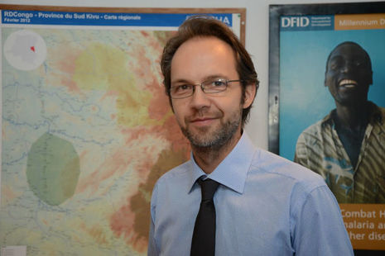
Christian Rogg is Director for Development and Open Societies at the UK’s Foreign, Commonwealth and Development Office (FCDO). Prior to this, he was Development Director at the British Embassy in Addis Ababa, Ethiopia, leading the largest UK aid programme in the world (2017-21). He also held senior leadership positions at the UK’s Department for International Development (DFID) in the Democratic Republic of Congo (2015-17), Nigeria (2012-15), Vietnam (2009-12) and Ghana (2006-9). He joined DFID’s Policy Division in London as an adviser in 1999 and subsequently led the Growth Team. He started his career in banking in Germany and worked as an economic development consultant to the World Bank, US Government and Inter-American Development Bank. Christian is a dual British-German national and was educated at universities in the US, Spain and the UK. He holds a PhD/DPhil in economics from the University of Oxford.

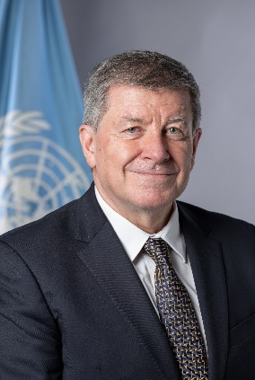
Guy Ryder is the Under-Secretary General for Policy in the Executive Office of the Secretary General. Mr. Ryder was most recently Director-General of the International Labour Organization (ILO) in Geneva after serving two successive terms since October 2012. He first joined the ILO in 1998 as Director of the Bureau for Workers’ Activities and from 1999, served as Director of the Office of the Director-General.
Mr. Ryder started his professional career in 1981 as an assistant at the International Department of the Trades Union Congress in London. From 1985, he held the position of Secretary of the Industry Trade Section of the International Federation of Commercial, Clerical, Professional and Technical Employees (FIET) in Geneva. In 1988, he became Assistant Director and – from 1993 - Director of the Geneva office of the International Confederation of Free Trade Unions (ICFTU). In 2002, he was appointed General Secretary of the ICFTU and was elected as the first General Secretary of the International Trade Union Confederation (ITUC) when it was created in 2006. He returned to the ILO in 2010 as Executive Director, responsible for international labour standards and fundamental principles and rights at work. Mr. Ryder studied Social and Political Sciences at the University of Cambridge and Latin American Studies at the University of Liverpool. He speaks English, French and Spanish.

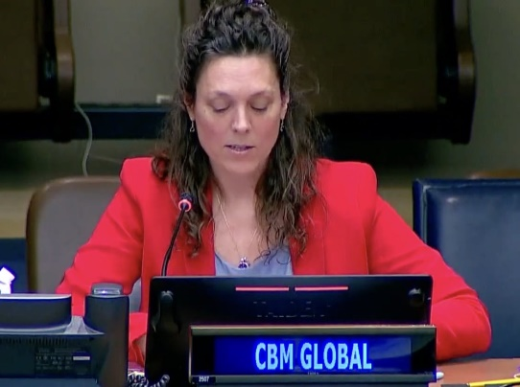
Dr. Elizabeth Lockwood works for CBM Global Disability Inclusion as the representative at the United Nations in New York. She focuses on developing advocacy strategies to raise awareness, build capacity, and lobby for the rights of persons with disabilities at the UN level. Dr. Lockwood focuses on the 2030 Agenda for Sustainable Development, disability data and statistics, financing for development, and accessibility. Dr. Lockwood co-organizes the Stakeholder Group of Persons with Disabilities with the International Disability Alliance and co-chairs the International Disability and Development Consortium’s UN Task Group.

