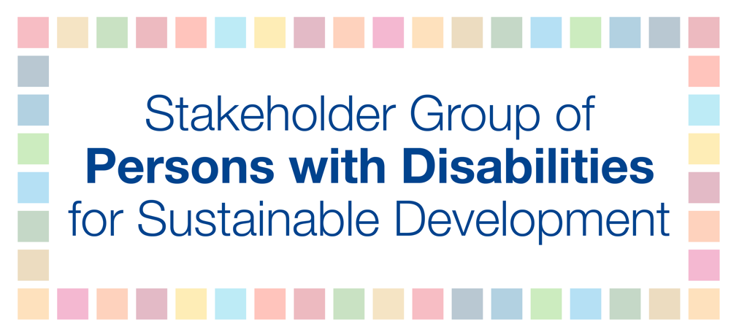

Thematic Group on Disaster Risk Reduction
Stakeholder Statement, Sendai Global Platform 2019

Excellencies, civil society colleagues, friends.

Today I speak to you on behalf of the Stakeholder Group of Persons with Disabilities, the focal point for UNDESA, ECOSOC and the GA for all UN Sustainable Development policies, and a member of the UN Major Groups and other Stakeholders coordination mechanism. The Stakeholder Group comprises persons with disabilities and their representative organizations, as well as mainstream development and DRR organizations working on disability inclusion.

Since 2015, Member States, UN agencies and civil society have been vocal in their aspirations and commitments arising from the Sendai Framework. But commitment without action is hollow.

This week, we have spoken of how to achieve a sustainable and inclusive society for all.

The Convention on the Rights of Persons with Disabilities, together with political commitments including the SDGs and the Dhaka Declaration on Disability and Disaster Risk Management tells us how we must and should do this.

The CRPD explicitly states that States are obliged to ensure that all women, men, boys and girls, older persons and indigenous persons with disabilities, living both in rural and urban areas are not left behind in humanitarian emergencies and disasters.

Yet we still remain among the most impacted in all crisis-affected communities, as a result of disasters, conflicts and as a consequence of climate change. We are two to four times more likely to die in a disaster. Women with disabilities are three times more likely to experience sexual violence than their peers without disabilities. Multiple and intersecting forms of discrimination also contribute to our marginalization.

And compounding all of this, we continue to be regarded solely as recipients of aid and beneficiaries of charity, not as actors for change.

Our motto is: “Nothing about us, without us”, and the Sendai Framework reflects this as a critical component to achieve inclusive DRR. Yet national DRR strategies continue to exclude us. Target E - the number of national and local disaster strategies to be developed by 2020 – will only contribute to our marginalization if persons with disabilities remain excluded from the design, planning, implementation, assessment and monitoring of these strategies.

Our expertise is critical to your understanding of how to identify and remove the attitudinal, communicational, informational and physical barriers we face, and to inform our collective practice. Removing barriers for persons with disabilities establishes a society which is inclusive for everyone.

There are clear steps that can be taken now by Member States, UN agencies and all relevant stakeholders to achieve this, before, during and after disasters:

- Partner with, consult, empower and actively engage persons with disabilities and our representative organizations to ensure our full inclusion and meaningful participation.

- Collect, analyze and apply data, disaggregate by disability, as well as gender and age, using the Washington Group Short Set of Questions and the UNICEF Child Functioning Module.

- Report on the situation of persons with disabilities using the Sendai monitoring mechanism, as well as the CRPD, treaty body and 2030 Agenda monitoring mechanisms and commitments contained in the Dhaka Declaration.

- Collectively build our technical, financial and human resources to ensure that organizations of persons with disabilities, mainstream organizations, UN agencies, governments, donors, and other relevant stakeholders have the capacity and knowledge to develop and implement DRR strategies that are truly inclusive of persons with disabilities.

- Utilize our knowledge and experience to enhance the second-generation resilient society with accessible technology and assistive devices.

The inclusive and sustainable world we want will only be built if we work together.

We welcome the efforts to mainstream disability across stakeholder groups and the UN system and urge you to work with us—we have the knowledge and expertise to inform inclusive and accessible approaches that will ensure equality for all persons with disabilities.

We, persons with disabilities are not inherently vulnerable. Society places us in vulnerable situations. Realizing DRR strategies inclusive of persons with disabilities requires a change—and we are ready to work with you to achieve this.

