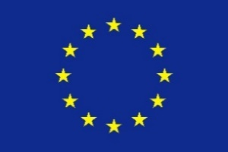
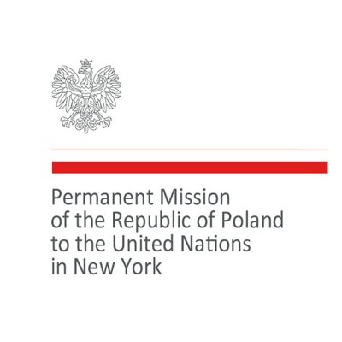
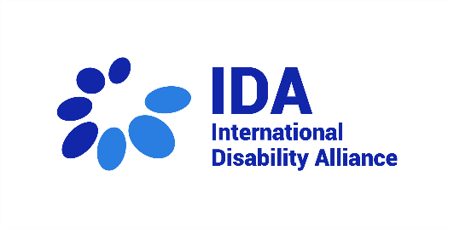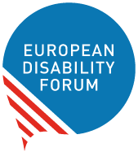
Four Months in War: Latest Update on Ukrainians with Disabilities
Ukrainians with disabilities have been disproportionately affected by Russia’s war of aggression on Ukraine. So that, the Permanent Mission of Ukraine to the United Nations organised this side event on the margins of the Conference of State Parties to the UN Convention on the Rights of Persons with Disabilities to bring attention to the situation of Ukrainians with disabilities. The event was co-sponsored by the International Disability Alliance, the European Disability Forum, the European Union, and the Permanent Missions to the UN of the Republic of Poland, the Republic of Lithuania, and the United States of America. It was broadcasted live, and a recording is available.
Marking the start of the first day of the 15th Conference of States Parties to the CRPD, 14 June, 2022, the event allowed several actors to share the most recent update on the situation of persons with disabilities affected by the war. States, disability rights experts and organisations of persons with disabilities also provided their recommendations and requests.
The main messages shared by speakers included:
- Over 143.600 persons with disabilities have been displaced as a result of the war.
- There are several issues that need to be addressed: non-accessible shelters, lack of access to food, inaccessible information, poor logistics and problems evacuating children with disabilities. Ukrainians with disabilities seeking refuge are also at risk of being segregated in residential institutions.
- Persons with disabilities and their representative organisations must be automatically included in all steps of emergency response and conflict resolutions, including in peace-building processes and in international bodies.
The event, moderated by Catherine Naughton, Director of the European Disability Forum, started with opening remarks by the Ukrainian Ambassador, Sergiy Kyslytsya; the Chair of the International Disability Alliance, Yannis Vardakastanis; and the Special Rapporteur on the Rights of Persons with Disabilities, Professor Gerard Quinn.
Ambassador Kyslytsya stated that the Russian aggression against Ukraine constituted the largest humanitarian crisis in Europe since World War II, underlining that 143,600 persons with disabilities have been displaced. He explained that persons with disabilities are more likely to experience the devastating effects of war, and expressed Ukraine’s commitment to their protection.
Mr. Vardakastanis highlighted that the International Disability Alliance established a new Disability Inclusive Emergency Response Mechanism to enhance disability inclusion in emergency response and coordination. He outlined the actions that the European Disability Forum and its members are taking to support Ukrainians with disabilities. He also referenced the important ad hoc meeting organised between representatives from Ukraine and the UN Committee on the Rights of Persons with Disabilities, which led to the adoption of a statement by the Committee. Recalling the obligations of countries to uphold the rights of persons with disabilities, including independent living, he shared his deep concerns regarding reports of institutionalization of persons with disabilities who fled the country.
Professor Quinn referred to the international mechanisms in place to protect Ukrainians with disabilities. He stated that there was still impunity to perpretators of crimes against humanity, especially against persons with disabilities. He added that he has an upcoming report on ensuring that the UN CRPD is mainstreamed within emergency response guidelines.
Presenters then addressed the current situation of persons with disabilities in Ukraine and in other countries.
Dariya Herasymchuk, Adviser - President’s Commissioner for Children’s Rights and Children’s Rehabilitation, talked about the disastrous situation faced by children with disabilities. She outlined that if the war continues, Ukraine will not be able to financially support children with disabilities. On a positive note, she said that the EU created a database of Ukrainians seeking shelter outside Ukraine. It will allow for tracking of all children with disabilities.
Tetyana Lomakina, Adviser - President's Commissioner for the barrier-free society issues, explained that it is impossible to know how many persons with disabilities remain in occupied and destroyed towns and villages. She stressed the need to provide support to persons with disabilities that are internally displaced, highlighting active programs to support employment and providing psychosocial support.
Larysa Bayda, Director of Department, National Assembly of Persons with Disabilities of Ukraine (NAPD) reported the numerous violations faced by Ukrainians with disabilities. Problems include non-accessible shelters, lack of access to food, inaccessible information and poor logistics. She explained that organisations of persons with disabilities must be included in humanitarian aid and that financial support should include disability-related costs.
MEP Dragos Pîslaru, Chairman of the Committee on Employment and Social Affairs of the European Parliament, underlined that the only solution is for Russia to stop its aggression against Ukraine. He explained that the European Parliament is concerned about the violence towards persons with disabilities, especially women and children. The Parliament brought attention to the need to support Ukrainians with disabilities, including adopting two resolutions since the start of the war. The Parliament is strongly committed to supporting Ukrainians with disabilities.
Pawel Wdowik, State Secretary and Plenipotentiary for the rights of persons with disabilities of Poland reported on the measures taken by his country, including a support system for Ukrainians with disabilities, set up by the government and NGOs, as well as access to healthcare and education. Poland also provides extensive information for Ukrainians arriving in the country.
Ambassador Rytis Paulauskas, Permanent Representative of Lithuania to the United Nations, explained that Lithuania’s main priority is to ensure that persons with disabilities can exercise their human rights. He stressed that all countries need to support Ukrainians with disabilities. He also said that Lithuanian disability organisations are actively engaged and connected with Ukrainian organisations and welcomed the efforts of Jonas Ruskus, Vice-Chair of the CRPD Committee.
Sara Minkara, U.S. Special Advisor on International Disability Rights, focused her intervention on the importance of involving and including persons with disabilities in short- and long-term measures. She explained that crises need to be looked at in different layers, from pre-planning, to response, to peace building and reconstruction. Persons with disabilities must be involved in all steps of the process. If done correctly, rebuilding the country could be an opportunity for better inclusion, moving towards community living and ensuring accessibility to all.

Yannis Vardakastanis closed the event, noting that the International Disability Alliance calls for international efforts that contribute to the reconstruction of an inclusive and accessible Ukraine.

