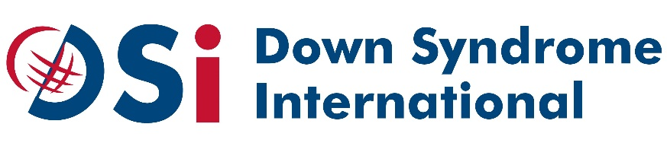
Terms of reference – DSI PROGRAMME Fellow
“Making DPOs equal partners of inclusive development in Africa” Program
in consortium with the International Disability Alliance (IDA) and funded by the Norwegian Agency for Development Cooperation (NORAD)
Position: Programme FELLOW
LOCATION: KAMPALA
For Ugandan nationals only

Organizational Context

ABOUT DSI
DSI is an international network working with organisations and individuals in 136 countries around the world. DSi’s members range from national and world regional Down syndrome advocacy organisations, to issue specific expert groups and advisors, to individuals with Down syndrome and those who advocate for them. DSi’s mission is to improve quality of life for people with Down syndrome worldwide and promote their inherent right to be included and accepted as equal members of society.
DSI’s main activities are:
- Policy and practice, information, support and advice - playing a lead or advisory role in a number of initiatives considering policies and practices on key issues affecting people with Down syndrome, including education, healthcare and human rights, working with our members and partners to ensure provision of accurate, up to date information and providing advice and support on demand to members and others who need it around the world.
- Network development and training - strengthening our membership network through improving communications, developing alliances and networks of self-advocates, involving members more in our activities and through the delivery of training designed to build the capacity of national member organisations, people with Down syndrome, their families and other stakeholders.
- Advocacy and campaigning - running global campaigns and events advocating for the rights of people with Down syndrome and participating actively in international disability and human rights forums, representing the global Down syndrome community.
GENERAL INFORMATION

SUMMARY
Down Syndrome International (DSi) is a member of the consortium formed by several members of the International Disability Alliance and which developed the programme called ‘Making DPOs equal partners of inclusive development in Africa’. The programme runs from 2020 to 2022 with funding from the Norwegian Agency for Development Cooperation (NORAD), and is aimed at supporting meaningful participation of persons with disabilities in development with a focus on Sub-Saharan Africa.

DSi’s section of the programme involves national level interventions in partnership with DSi member organisations in Kenya, Nigeria, Rwanda and Uganda. The key activities include:
- Technical training for national DPOs on rights-based advocacy strategies that are inclusive of the voices of people with Down syndrome and intellectual disabilities, with a focus on work and employment
- Training and support for national DPOs to establish and run self-advocacy groups of persons with Down syndrome
- Development of advocacy tools and programmes of advocacy activities in each country, led by the self-advocacy groups and with a focus on inclusive employment
- Production of a report on challenges related to the employment of people with Down syndrome and intellectual disabilities
- Collection of lessons learnt and recommendations, feeding into a global report
The Programme Fellow will work closely with DSi’s International Programme Team and national member organisations to implement these activities.

WORKING ENVIRONMENT

Mission: The Programme Fellow will support the implementation of DSi’s activities, working closely with the DSi International Programme Team and national member organisations. This will include ensuring all activities are in alignment with the UNCRPD and actively include the voices of persons with Down syndrome and intellectual disabilities.

Reporting to: DSi Programme Manager (Nathan Rowe).

JOB DESCRIPTION

POSITION: PROGRAMME FELLOW
LOCATION: KAMPALA
For Ugandan nationals only

Responsibilities:
- Provide support and training to DSi member organisations
  - Develop and maintain good working relationships with DSi’s members
  - Develop and deliver training to build the capacity of DSi’s members around human rights and advocacy, with a focus on the CRPD and the SDGs.
- Support implementation of employment advocacy projects in Kenya, Rwanda, Uganda, and Nigeria
  - Support management of project activities to ensure effective, participatory and collaborative delivery of project results
  - Work closely with DSi members involved in projects to ensure good communication and timely implementation of their project activities
  - Support development of policies, guidelines and other documents to support DSi’s project work
- Contribute to teamwork and events
- Ensure regular reporting on progress of his/her work

EMPLOYMENT SPECIFICATIONS
Qualifications:
- Undergraduate or an equivalent degree in a relevant field, or equivalent lived or associative experience
- Good understanding of the UNCRPD and disability rights
- Proven experience of working with the disability movement and DPOs in the country of the fellowship
- Experience of programme implementation is an asset
- Experience of working directly with people with Down syndrome and/or intellectual disabilities is desirable
- Experience of delivering training on the CRPD, SDGs and broadly on human rights and/or advocacy
- Strong communication and interpersonal skills
- Knowledge of English and the local language is required
- Ability to write a concise and analytical report in English

Salary: Commensurate with experience and as per standards of the duty station.

Reasonable accommodation will be provided upon the request of the selected candidate.

Duration: Initial contract will be for a year with the possibility of renewal for a second year.

Travel: The position will include travel to the countries where the project is being implemented.

Interested candidates are requested to send a cover letter explaining their suitability for the position(s) along with a copy of their resume and two references to consultancy@ida-secretariat.org not later than 15 August 2020.

Note: The subject line of the e-mail should be “Application for position of DSi Programme Fellow, Uganda”. Only short-listed candidates will be contacted. This position is open for Ugandan nationals only.

