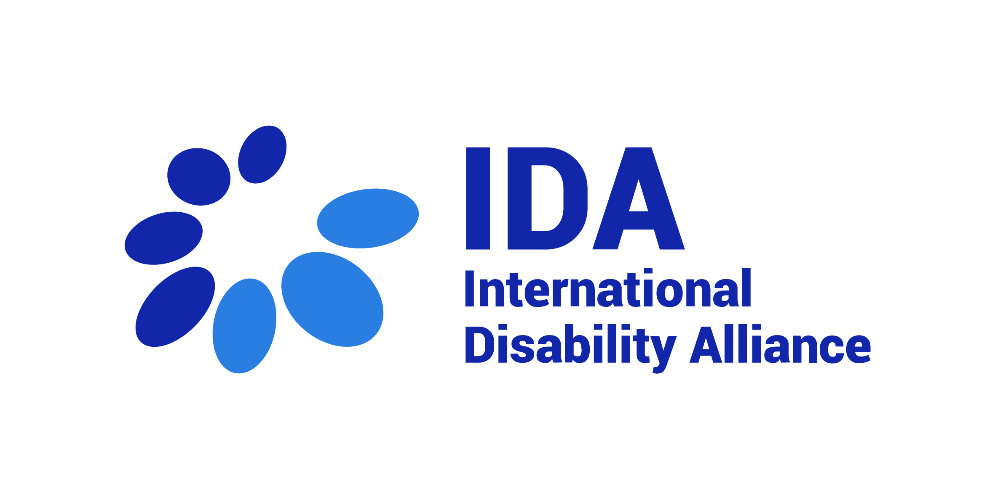
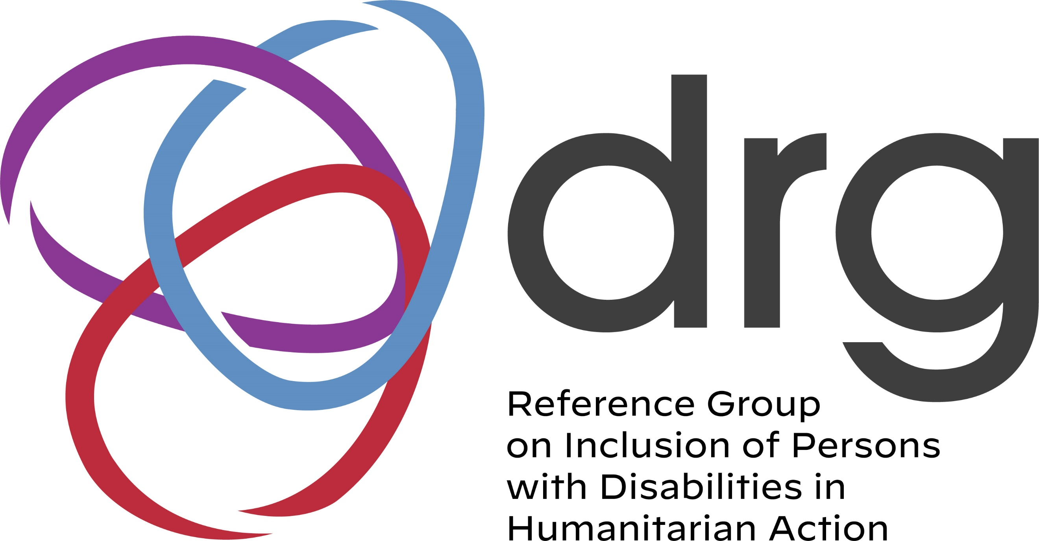

DRG OPD Regional Fellowship
Terms of Reference
- Background
Position: DRG OPD Regional Fellowship, IDA
Description of the Organization: The International Disability Alliance (IDA) was established in 1999 and is a network of eight global and, six regional organisations of persons with disabilities (DPOs). IDA advocates at the UN for a more inclusive global environment for persons with disabilities and their organisations. The Convention on the Rights of Persons with Disabilities (CRPD) is our touchstone. IDA is invested in ensuring that the 2030 Agenda and the Sustainable Development Goals are inclusive and in line with CRPD. IDA supports organisations of persons with disabilities worldwide to take part in UN and international human rights processes and use international accountability mechanisms. With member organisations globally, IDA represents the estimated one billion people worldwide with disabilities. This is the world’s largest and most frequently overlooked marginalised group. More information is available on www.internationaldisabilityalliance.org.

About IDA Fellowship Programme: The IDA Fellowship Programme has a dual objective of providing support to IDA members’ operational capacity to advance the rights of persons with disabilities and to build the capacities of individual disability activists as contributors to the disability rights movement. IDA fellowships provide a unique combination of opportunities for learning, mentorship, exposure to different policy, advocacy and monitoring processes, and contribution to initiatives aimed at advancing the rights of persons with disabilities in the Global South. Fellowships are mutually beneficial for the fellow and the hosting organisation.

Fellowship advert
Background on Fellowship
The Inter-Agency Standing Committee (IASC) Guidelines on Inclusion of Persons with Disabilities in Humanitarian Action (the IASC Guidelines) were endorsed by the IASC in October 2019 and launched in New York in November 2019. While launch of the IASC Guidelines created substantial momentum to promote the rights of persons with disabilities impacted by humanitarian crises, there remains a need to translate these commitments into practice
The Reference Group on Inclusion of Persons with Disabilities in Humanitarian Action (DRG) was launched in February 2020 to address this need. The Reference Group brings together humanitarian actors (including UN entities and NGOs) and organizations of persons with disabilities (OPDs) to strengthen inclusion of persons with disabilities in humanitarian action, including through roll out of the IASC Guidelines. More than 18 months on since establishment of the Reference Group, it has more than 170 members, including more than 20% who are OPDs. The DRG is currently co-chaired by International Disability Alliance, CBM-Global and UNICEF.

In line with the Convention on the Rights of Persons with Disabilities (CRPD), one of the priority areas of work for the DRG is to strengthen engagement of OPDs, and a specific working group has been established to ensure a focused approach to advancing on this priority.
In line with the above, the DRG has received a grant from USAID/BHA to implement a project entitled ‘Capacity building of OPDs- strengthening disability inclusive humanitarian action’ (the project).
The project will contribute to ensuring the active participation, coordination, and meaningful consultation of organizations of persons with disabilities (OPDs) in humanitarian action. Specifically:
1. To have a set of core capacity development introductory resources developed and rolled out with OPDs, in multiple accessible formats and languages to support capacity of their members to engage in key humanitarian process at global, regional, and country levels.
2. To have an active core cadre of OPDs whose staff and members have capacity to effectively engage with humanitarian actors to influence policy, programming, and implementation to ensure humanitarian action is inclusive of and accountable to all persons with disabilities, especially under-represented groups.
3. To capture the perspectives and experiences of OPDs on how to strengthen inclusive humanitarian action and, more specifically, localization efforts.

Mission of the DRG OPD Fellows
Under the umbrella of the project, the DRG OPD Regional Fellows will have the mandate to support the work of the DRG, to work towards:
- Development, dissemination, and communication of resources developed and rolled out with OPDs, in multiple accessible formats and local languages

- Supporting the mobilization of OPDs in the region through the strengthening of network and community of practice

- Supporting linkages of OPDs from regional networks/ humanitarian contexts to engage with the wider work of the DRG

C. Criteria for Fellowship Applicants

Role and Responsibilities
- Support communications and outreach to OPDs in their region, in English and in their local languages.
- Promote and support refinement of materials in English, and responsive to context.
- Support to proofing of translations/ adapting accessible plain language versions.
- Supporting outreach for active regional participation across all activities of the project.
- Help strengthen building of networks and community of practice for exchange and learning.
- Support capture and documentation of learning, case studies and feeding into learning briefs on key areas – and of taking forward regional perspectives into the wider DRG.

Reporting line of the DRG OPD Fellows
  - The DRG OPD Regional Fellows will report to IDA’s Fellowship Program managed by IDA Capacity Building Unit, which would be accountable to coordinate with the DRG Project Coordination Group.

Duration
  - The position shall apply full-time from January 2022 for twelve (12) months, with possible extension.

Location
The fellows will work from home; however, he\she may be hosted remotely in OPDs in countries experiencing humanitarian emergencies and connected with OPD networks in the region. Some regional travel to participate in trainings may be required should circumstances permit.

Skills and Qualifications

Requirements
- At least 2 years of relevant work experience within the disability rights movement
- A graduate degree or equivalent work experience in human rights, humanitarian system, law, public policies, international development or public affairs, social sciences or similar
- Being a person with disability with lived experience of either working in humanitarian action or support to people affected by humanitarian emergencies
- Demonstrable knowledge of the UN Convention on the Rights of Persons with Disabilities
- Demonstrable knowledge of Humanitarian Action processes and systems, including in disasters, complex emergencies and/or displacement
- Good written and oral communication skills in English and in local language
- Commitment to the human rights of persons with disabilities and experience of supporting meaningful engagement of organisations of persons with disabilities, including from underrepresented groups
- Good sense of diplomacy, and ability to manage complex and multi-stakeholder communication
- Innovative and creative thinker, with the ability to problem solve, e.g. use humour to engage and defuse tensions
- Excellent inter-personal skills including active listening skills and the ability to work within a multi-cultural team in decentralized locations
- Ability to work collaboratively, to multi-task, and work under pressure, as well as to meet multiple deadlines
- Experience of working with a cross section of all disability constituents with experience of mentoring persons with disabilities and supporting organizations of persons with disabilities
- High level of computer literacy and PC skills
- Practical experience in communication and use of social media
- Flexibility and capacity to work with limited supervision
- Knowledge of communication and information accessibility requirements
- Demonstrated experience working with underrepresented groups of persons with disabilities.

Desirable requirements
- Persons with disabilities from the underrepresented groups are highly encouraged to apply
- Candidates with work and/or life experience in Africa, Asia, Latin America, Middle East and North Africa or Pacific are highly encouraged to apply
- Previous experience working in similar position
- Being an alumni or having attended equivalent Bridge CRPD SDGs Training Initiative

Other considerations
- Willingness and ability to work occasionally at non-standard hours, in different time zones and using multiple modes of communication, e.g., traditional media, social media etc.

