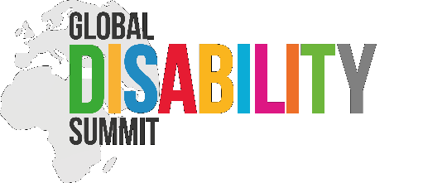

Terms of Reference

GLOBAL DISABILITY SUMMIT 2025

International Sign Language Interpreters

I. What is the Global Disability Summit

The Global Disability Summit (GDS) is an international mechanism created in 2017 following conversations between several governments and the International Disability Alliance (IDA). The GDS is mandated to promote investment in disability inclusive development and humanitarian action, with an intentional focus on developing countries. It offers a unique and concrete mechanism for collecting ambitious, and measurable commitments, critical to achieving real change for persons with disabilities. A substantive added value of the GDS mechanism to other existing mechanisms is its ability to bring together a wide variety of stakeholders from governments, international agencies, civil society organisations, OPDs, as well as academia, private corporations, and local councils, through extensive consultations. It gives them space to discuss, question, experience and reflect on how international advocacy and grand commitments adopted by governments can translate into the daily lives of people with disabilities all over the world.

Every three years, the GDS mechanism culminates in a two-day conference. A gathering of stakeholders (Governments, UN and multilateral agencies, private sector, and civil society), to hold high level discussions and present commitments in the form of thematic panels, high-level presentations, and more broadly conversations around the pre-identified priorities of the Summit.

More information on the Global Disability Summit can be found here.

II. GDS2025

The Global Disability Summit 2025 will be co-hosted by the International Disability Alliance, the government of Germany and the government of Jordan.

GDS2025 will happen in Berlin, Germany, on April 2nd and 3rd, 2025. The event will have in-person and remote attendance and will tentatively run from 9 AM to 6 PM CET on both days.

While the agenda and thematic priorities for the conference are yet to be determined, we anticipate having a main room with high-level discussions, thematic panels, and presentations of concrete pledges, throughout the day.

III. SERVICES REQUIRED

To this extent, we are looking for 10 International Sign Language Interpreters for the days of the Summit.
This call is open for all WASLI Accredited and Pre-accredited International Sign Interpreters.

Non accredited International Sign Interpreters can apply by providing sufficient evidence on exposure to the international conferences and a personal recommendation by WASLI Accredited Interpreter.

IV. HOW TO APPLY

All interested candidates should send an email with official quotation (with daily fees indicated) to tenders@ida-secretariat.org with subject “GDS2025 international sign language interpreters”, by 01 October 2023.

