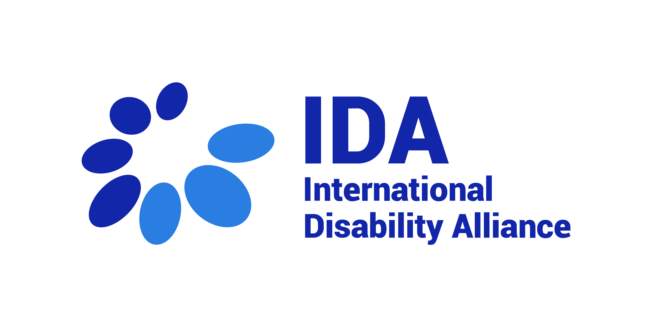
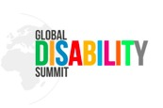

Global Disability Summit Fellowship
IDA’s Capacity Building Unit
Application Package
- Background
Position: GDS Fellowship Latin America, IDA
Description of the Organization: The International Disability Alliance (IDA) was established in 1999 and is a network of eight global and, six regional organisations of persons with disabilities (DPOs). IDA advocates at the UN for a more inclusive global environment for persons with disabilities and their organisations. The Convention on the Rights of Persons with Disabilities (CRPD) is our touchstone. IDA is invested in ensuring that the 2030 Agenda and the Sustainable Development Goals are inclusive and in line with CRPD. IDA supports organisations of persons with disabilities worldwide to take part in UN and international human rights processes and use international accountability mechanisms. With member organisations globally, IDA represents the estimated one billion people worldwide with disabilities. This is the world’s largest and most frequently overlooked marginalised group. More information is available on www.internationaldisabilityalliance.org.

About IDA Fellowship Programme: The IDA Fellowship Programme has a dual objective of providing support to IDA members’ operational capacity to advance the rights of persons with disabilities and to build the capacities of individual disability activists as contributors to the disability rights movement. IDA fellowships provide a unique combination of opportunities for learning, mentorship, exposure to different policy, advocacy and monitoring processes, and contribution to initiatives aimed at advancing the rights of persons with disabilities in the Global South. Fellowships are mutually beneficial for the fellow and the hosting organisation.

Fellowship advert
Background on Fellowship
In 2018, the UK Department for International Development (DFID), along with the International Disability Alliance (IDA) and the Government of Kenya, hosted the first Global Disability Summit, which was preceded by a Civil Society Forum. The Global Disability Summit (GDS) 2018 represented a keystone momentum placing the disability movement upfront in the disability inclusive development. Commitments towards the GDS recognize the importance of capacity building efforts and the unique nature of technical advice made by persons with disabilities and their representative organizations. This interest towards capacity building and technical responses

span across governments, donors and development actors who have so far not often directly engaged with the disability movement and are now making requests for technical assistance.
Through this platform, one hundred and seventy-one (171) national governments, multilateral agencies, donors, foundations, private sector, and civil society organizations made nine hundred and sixty-eight (968) individual commitments anchored on seven (7) central themes of the GDS 2018. After this historical moment, the focus shifted to implementation and translation of the Commitments into tangible targets in line with government’s priorities and development plans.
With the upcoming GDS, it is imperative to begin building awareness and to encourage reflection upon the various commitments made. In this process, the role of persons with disabilities and their representative organizations in these different phases is critical and in the spirit of the Charter of Change, persons with disabilities must be at the front and centre of the change.

GDS Secretariat
The GDS Team, under the management of the GDS Senior Manager, has been preparing for GDS 2022, monitoring progress of ongoing commitments, and ensuring that accountability mechanisms are in place to incentivise genuine and sustained progress. The GDS Secretariat is guided by and accounting to the GDS co-hosts for strategic orientations and linking with Technical Advisory Groups as well as a broader circle called the ‘Partnership Forum’. The Civil Society Reference Group is now actively meeting once a month to discuss themes for the upcoming summit. The 2022 Summit has now been confirmed to take place virtually between 15-17 February.
Furthermore, from October 2020 to April 2021, 27 National and 1 regional consultation have taken place across the Global South, supported by IDA members and allies, which fostered the consultative aim of the GDS, bringing the concerns and experiences of OPDs from grassroots to evaluate the progress of commitments in their countries.
Also, for the first time, the GDS will comprise an entire day of discussions on youth with disabilities. The aim of the Youth Disability Summit is to raise ideas and concerns of the estimated 200 million youth with disabilities worldwide. This day will be held virtually on February 14th, 2022.
The Global Youth Summit will draw attention to the topics that are particularly important for youth with disabilities such as inclusive education, deinstitutionalization, access to employment, climate change, new technologies, among others. It will also accelerate the involvement of youth with disabilities in the implementation of the CRPD and the Sustainable Development Goals by raising awareness on the importance of their active participation in policy making towards government representatives and other stakeholders. It can ideally deliver real and lasting change in the lives of youth with disabilities around the world, with new strong commitments to also recover from the pandemic.

Mission of the GDS Latin America Fellow

The IDA GDS Fellows will support IDA and the GDS secretariat in the co-hosting and implementation of the GDS and to work towards:

Supporting the stakeholders group comprising of Governments, INGOs, UN agencies and Private sector companies towards making commitments for the next two-years period from 2022, building on the 2018 commitments and the reflections shared by OPDs in the national and regional level consultations.

Supporting the organisation of national and regional workshops, satellite events, and other activities both in person and online, towards the GDS 2022.

Supporting the updates to the GDS website, currently in development, towards providing up to date information regarding commitments and the progress made on those, based on stakeholder consultations.

C. Criteria for Fellowship Applicants

Role and Responsibilities

Supporting the development of commitments towards the 2022 GDS

Support the consultative process with stakeholders towards gaining more support for the GDS 2022 and more commitments for the next five-year period reflecting the priorities identified by the OPD consultations.

Supporting the organization of events towards GDS 2022

Support the organization and facilitation of in person and online events at the national and regional levels on the GDS 2022, including through identification of potential allies and new stakeholders.

Following up with stakeholders regarding potential areas of commitments and supporting communication around the same.

Support with timely documentation, reporting and communication

Support the development of quality materials to communicate about the GDS national consultations, satellite events and other events leading up to GDS 2022,

Ensure timely monitoring, reporting and updates on the GDS national consultations, satellite events and other events, including data disaggregation by region, gender, age, impairment, and other intersectional identities where relevant,

Closely working in collaboration with IDA communication and MEAL teams.

Hosting and management of the Youth Fellow

The GDS Fellow will report to the GDS Senior Manager, who will in turn be supported by IDA’s Capacity Building Unit in the management of the Fellow.

Skills and Qualifications

Requirements

At least 3 years of relevant work experience within the disability rights movement,

A graduate degree or equivalent work experience in Human Rights, Law, Public Policies, International Development or Public Affairs, Social Sciences or similar

Knowledge of human rights reporting process before the UN system, and of the UN Convention on the Rights of Persons with Disabilities, as well as the Sustainable Development Goals

Good knowledge of development agenda and dynamics

Good written and oral communication skills in English

Commitment to the human rights of persons with disabilities and experience of supporting meaningful engagement of organisations of persons with disabilities, including from underrepresented groups

Ability to work collaboratively, to multi-task, and under intense pressure, as well as to respect multiple deadlines

Practical experience in communication and use of social media

Flexibility and capacity to work with limited supervision

Knowledge of communication and information accessibility requirements

Desirable requirements

Previous experience working in similar position

Being Bridge CRPD-SDG alumni or having attended equivalent trainings in the past

Work and/or life experience in Global South countries

Based in Latin American region

Other considerations

Daily access to internet and a personal computer

Willingness and ability to work occasionally at non-standard hours, in different time zones

Willingness to remain available on instant communication modes like WhatsApp.

Persons with disabilities are highly encouraged to apply, in particular from the underrepresented groups

Duration
The position shall apply from November 2021 for 07 (seven) months, unless extended by mutual agreement in writing by the Parties.

- Application Form

- Confidential. All information given on the application will be treated in a confidential manner.

- Please complete in type only. Once completed, please return this form via email to Consultancy@ida-secretariat.org indicating in the subject line: “GDS Latin America Fellowship”.

- We kindly ask candidates not to attach a separate CV or motivation letter to the application.

- After receiving your application, a confirmation of receipt will be sent to you via email. Should you not receive a confirmation, please contact the IDA Secretariat by email.

- Closing date for receipt of applications: 22 October 2021.

- Only completed application forms will be accepted. Any applications received after the closing date will not be considered. Only shortlisted applicants will be informed about the next steps of selection process.

- Note: IDA Board Members and Board Member of IDA’s Member Organizations are not eligible for this Fellowship Programme.

1. Forename(s) or given name:
Surname:
Home address:
Telephone (cellular):
E-mail:

2. Education
General education (schools from age 16)
Name and address  of school | From/to | Qualifications obtained  (level and grade)

Further/higher education
Name and address  of college/university | From/to | Full-/  part-time | Qualifications obtained

3. Training and development
Please give details of any training courses attended which are of direct relevance to your application.

4. Membership of technical or professional bodies

5. Present and previous occupations
Please give details of your occupation(s) starting with the most recent. Please include any unpaid work that is relevant to the post and explain any gaps.
Employer's name and  address (please start with current/most recent) | From/to  (month/year) | Position held including  brief description of your duties

  - Language skills, including sign language
6.1 Reading skills
Language | Excellent | Very good | Good | Basic

6.2. Writing skills
Language | Excellent | Very good | Good | Basic

6.3. Verbal skills
Language | Excellent | Very good | Good | Basic

7. Computer literacy
Please indicate your computer knowledge stating all the software programmes you are confident using.

8. Please explain how you meet the employment specifications and give us any further information about yourself that is relevant to this application. Please keep your response to one page. (NOTE: This section of the application is one of the most important and will be considered as your motivation letter to the vacant position within our organisation)

9. Supplementary information
What is your preferred reading medium? Please underline:
Ordinary print/digital format

10. If you were short listed for interview, would you have any special requirements such as timing, wheelchair access or the presence of an interpreter or signer? Please specify.

11. Have you ever been convicted of a criminal offence?

12. Offers of employment/contracts are subject to receipt of satisfactory references. Please provide the names, addresses and telephone numbers of at least two referees, one of whom should be your present or most recent employer or an academic referee if more appropriate. Referees will not be contacted without your prior permission.
A. Name:
Position: ……………………………………………………………………………….
Address:
Telephone number: ………………………………………………
E-mail:
What is your connection with this referee?
May we approach this referee prior to interview?

B. Name:
Position: ……………………………………………………………………………….
Address:
Telephone number: ………………………………………………
E-mail:
What is your connection with this referee?
May we approach this referee prior to interview?

C. Name:
Position: ……………………………………………………………………………….
Address:
Telephone number: ………………………………………………
E-mail:
What is your connection with this referee?
May we approach this referee prior to interview?

Declaration
I declare that the information provided on this form is correct to the best of my knowledge and understand that any information submitted in connection with employment and subsequently found to be incorrect or deliberately misleading could lead to dismissal without notice.

Signed Date

