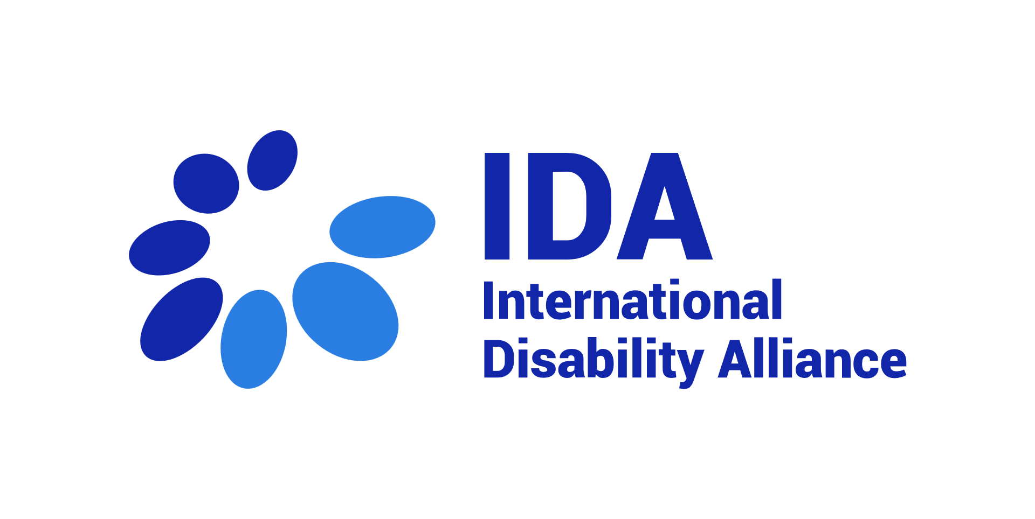

TERMS OF REFERENCE - SHORT-TERM CONSULTANCY

Drafting a Report Analysing the Normative Framework of CRPD Article11 Regarding States Obligations on Disaster Preparedness, Response and Recovery

About IDA
The International Disability Alliance (IDA) was established in 1999 and is a network of eight global and six regional organisations of persons with disabilities (DPOs), representing the voice of the estimated one billion persons with disabilities worldwide. IDA is a network representing members that are organisations of persons with disabilities. IDA’s unique composition as a network of international DPOs allows it to act as an authoritative and representative voice of persons with disabilities in the United Nations (UN) system.

IDA’s mission is “To advance the human rights of persons with disabilities, as a united voice of organizations of persons with disabilities, utilizing the Convention on the Rights of Persons with Disabilities and other human rights instruments”. IDA’s longer-term goal is that “the United Nations framework (the General Assembly, Security and Human Rights Councils, treaty bodies and development agencies), bilateral and multilateral development agencies, regional organizations and human rights instruments contribute to create an enabling environment for DPO advocacy and government capacity to implement the UN CRPD at national level”.
More information about IDA: www.internationaldisabilityalliance.org

Background of the Project

Article 11 of the UN CRPD Convention is a unique tool to ensure inclusion and participation of persons with disabilities and their representative organizations in design, implementation and monitoring State policies and programs on emergency preparedness, response and recovery. The decision of the CRPD Committee to dedicate its upcoming General Comment to interpretation of this provision is a great opportunity to clarify and strengthen States obligations to respect, protect and fulfil rights of persons with disabilities in situations of risk and humanitarian emergencies.
The International Disability Alliance (IDA), as the global network of organizations of persons with disabilities is committed to support advancing interpretation and implementation of the CRPD convention including through facilitating knowledge production and documenting perspective of persons with disabilities and their organizations on issues affecting them. In particular, due to additional barriers faced by persons with disabilities during emergencies as well as unclarities around States obligations to ensure protection and safety of persons with disabilities in these situations, IDA highly prioritizes development of a comprehensive and strong General Comment on Article 11 reflecting perspective of disability movement within its diversity.

Since 2021, together with four partner organizations IDA has been implementing a project entitled Putting Persons with Disabilities at the Center of Disaster Preparedness and Response funded by Germany Federal Foreign Office (FFO). The vision of the project is to foster inclusive approaches to disaster risk reduction and humanitarian action. It brings together key actors from the international to the community level to generate knowledge, develop capacity and explore best practice with regards to the implementation of the Sendai Framework and the implementation of the IASC Guidelines on the Inclusion of Persons with Disabilities in Humanitarian Action.
IDA is leading the project implementation at the global level. One of the main advocacy goals of the project is to encourage collaboration amongst key actors to promote and advance the inclusive disaster risk reduction agenda and to position it at the center of international debate.

Background of the Consultancy
As the lead of the activities related to regional and global advocacy under the above-mentioned project, IDA is hiring a consultant to produce a report elaborating some elements of CRPD Article 11 as a contribution to the process of developing CRPD Committee upcoming General Comment.

Services Required

The consultant is responsible to conduct desk research, Key Informed Interviews, and consultations required, and draft a report elaborating States obligations under Article 11 of the UN Convention on the Rights of Persons with Disabilities during Disaster preparation, response and recovery.

While the exact scope and outline of the report will be clarified throughout the development process and based on perspective shared by experts and OPD representatives, the below points will be guiding the scope of the final product:

- The report will focus on States obligations arising from CRPD Article 11 in disaster preparation, response and recovery;
- - The analyses of State obligations should consider CRPD negotiations and the concluding observations by the CRPD Committee on more than 100 State reviews, in what relates to DRR, and identify trends, gaps, unsettled issues and areas not still tackled by the Committee.
- - The report should consider including good and innovative practices by States in implementing CRPD obligations, in particular in connection with under-represented groups in this area of law and practice.
- Disaster would include both “natural” and “man-made” disasters including pandemics and health emergencies as well as disasters caused or aggravated due to climate change;
- The report will not include States obligation during armed conflict;
- obligations during recovery phase will be analysed to the extent related to emergency situation and within the scope of Article 11.

Deliverables and Due Dates

- First draft of the report including completing desk research and analysis of CRPD and other related jurisprudence: August 15 2023 [12 working days]
- Advanced draft including perspectives shared during consultations and interviews and addressing comments to the first draft: September 15, 2023 [5 working days]
- Final version of the report ready for design and a presentation summarizing the main points: September 30, 2023 [3 working days]

Total Working Days required: 20 (twenty) working days.
Tentative Starting day: July 5, 2023
Tentative closing day: September 30, 2023

Qualifications of the Consultant
- Strong knowledge of international human rights law including rights of persons with disabilities as articulated in UN CRPD.
- Knowledge of Disaster Risk Reduction laws, policies, and practices
- Demonstrated skills in legal analysis and drafting high-level reports and papers.
- Demonstrated strong writing skills in English and addressing various feedback and comments including collecting views of different stakeholders.
- Competent persons with disabilities are strongly encouraged to apply.

Contracting and Remuneration

- Payment and financial compensation will be subject to location and experience.
- A consultancy contract (as per Swiss law) will be signed between the selected consultant and IDA.
- Applicants are invited to submit a copy of their passport and commercial/consultant registration/tax numbers. Only applicants with valid commercial and/or consultant registration and/or tax numbers will be considered.
- Payments will be made in several instalments and upon successful completion of the deliverables and submission of invoices.

How to Apply
The interested consultant should submit a letter of interest, CV including link of prior published papers, and financial offer indicating the total fees for 20 working days during the specified timeline latest by June 18, 2023 to consultancy@ida-secretariat.org with the subject “Consultancy application – GC Article 11 Research

Note: Only Shortlisted Candidates Will Be Contacted

