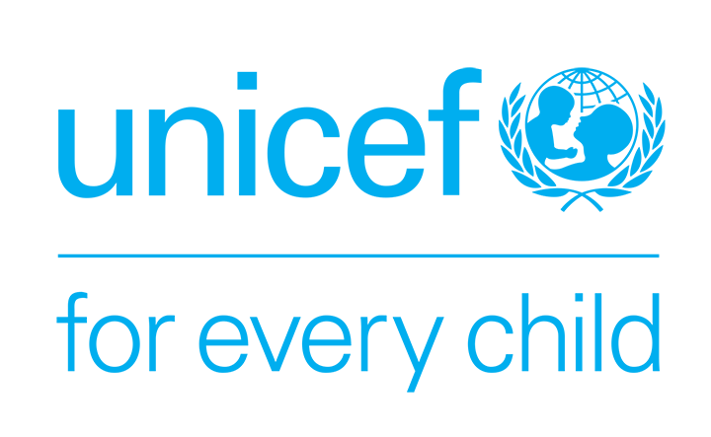
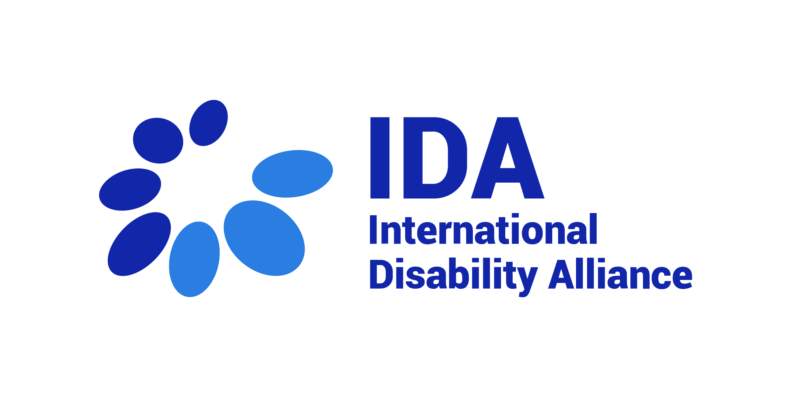

Fellowship IDA-UNICEF Youth
IDA’s Capacity Building Unit
Application Package
- Background
Position: Fellowship IDA-UNICEF Youth, IDA
Description of the Organization: The International Disability Alliance (IDA) was established in 1999 and is a network of eight global and, six regional organisations of persons with disabilities (DPOs). IDA advocates at the UN for a more inclusive global environment for persons with disabilities and their organisations. The Convention on the Rights of Persons with Disabilities (CRPD) is our touchstone. IDA is invested in ensuring that the 2030 Agenda and the Sustainable Development Goals are inclusive and in line with CRPD. IDA supports organisations of persons with disabilities worldwide to take part in UN and international human rights processes and use international accountability mechanisms. With member organisations globally, IDA represents the estimated one billion people worldwide with disabilities. This is the world’s largest and most frequently overlooked marginalised group. More information is available on www.internationaldisabilityalliance.org.
Empowering youth with disabilities: With the support of the Norwegian Agency for Development Cooperation (Norad), IDA is partnering with the United Nations’ Children Fund (UNICEF) to advance the implementation of the CRPD and the Sustainable Development Goals (SDGs) for all with a focus on the inclusion, empowerment and technical expertise of youth with disabilities, particularly in the sub-Saharan and East African regions. The project will take a participatory approach involving youth with disabilities in the design, planning and execution of the activities thereby further strengthening their capacities, following and anchored to the UN strategies or frameworks. It is thought as the initial phase of a longer initiative, setting the foundations for mobilisation of youths with disabilities and with a longer-term plan for scaling their contributions to decision-making and engagement as agents of change.
About IDA Fellowship Programme: The IDA Fellowship Programme has a dual objective of providing support to IDA members’ operational capacity to advance the rights of persons with disabilities and to build the capacities of individual disability activists as contributors to the disability rights movement. IDA fellowships provide a unique combination of opportunities for learning, mentorship, exposure to different policy, advocacy and monitoring processes, and contribution to initiatives aimed at advancing the rights of persons with disabilities in the Global South. Fellowships are mutually beneficial for the fellow and the hosting organisation.

Fellowship advert
Background on Fellowship
There is growing evidence that young persons with disabilities throughout the world are disproportionately isolated within their own communities and are far less likely than their peers to achieve the same educational and employment outcomes, and in many cases, they are unable to begin families or establish healthy sexual partnerships as is seen with their non-disabled peers.
Many, if not all of the difficulties have been drastically exacerbated by the COVID-19 pandemic and related precautionary measures, particularly in the Global South. Youth with disabilities have also experienced disruptions in their access to essential services related to assistive devices, sexual and reproductive health services and rehabilitation. Physical distancing has often resulted in social isolation, having been separated from their friends and colleagues.
At the same time, youth-led organizations of persons with disabilities (OPDs) or wings of OPDs including in the sub-Saharan and East African region have taken innovative steps to create a sense of community and to continue dialogue among their peers in these times by leveraging and participating in newer forms of communication and media which has highlighted their potential to be agents of change and to adapt to an ever-changing world, particularly the emergence of new technologies.
Due to the overall under-resourcing of the disability sector particularly in relation to rights-based approaches, youth with disabilities, particularly those from underrepresented groups, are often not included in the limited capacity building initiatives that exist for persons with disabilities around monitoring of commitments on human rights and development and to contribute towards treaty body jurisprudence. Young persons with disabilities hold diverse identities including gender, sexuality, racial, ethnic, and class identities, but there is little discussion of intersectional approaches to build their capacity to be leaders within both the disability movement and other movements.

Youth Disability Summit
The Government of Norway, the International Disability Alliance and the Atlas Alliance are co-hosting the second Global Disability Summit (GDS22), in February 2022.
The event will be held online with the themes to be prioritized based on the consultations with OPDs. And for the first time, the GDS will comprise a whole day of discussions on youth with disabilities. The aim of this Youth Disability Summit is to raise ideas and concerns of the estimated 200 million youth with disabilities worldwide.
This day will be held virtually on February 14th, 2022.
The Global Youth Summit will draw attention to the topics that are particularly important for youth with disabilities such as participation of youth in OPDs and youth mainstream organizations, inclusive education, deinstitutionalization and community inclusion, access to employment, climate change, new technologies, humanitarian action, among others. It will also accelerate the involvement of youth with disabilities in the implementation of the CRPD and the Sustainable Development Goals (SDGs) by raising awareness on the importance of their active participation in policy making towards government representatives and other stakeholders. It can ideally deliver real and lasting change in the lives of youth with disabilities around the world, with new strong commitments to also recover from the pandemic.

Mission of the Youth Fellow
The main mission of the Youth Fellow is to support the Capacity Building Unit in furthering the existing work supported by IDA around enhancing knowledge, capacity and leadership of youth with disabilities, particularly in sub-Saharan and East Africa, towards their full and effective participation in the global disability-inclusive sustainable development agenda.

C. Criteria for Fellowship Applicants

Role and Responsibilities
- The role of the Youth Fellow would be supporting IDA’s work to strengthen the global and regional networks of youth persons with disabilities by:
- Supporting the Youth Committee and the Youth Caucus (List Serv), Whatsapp group and the IDA youth webpage.
- Supporting the hosting of webinars in different languages for youth with disabilities, including related to capacity building and on experiences with the COVID-19 lockdown and aftermath in continuation of ongoing engagements.
- Supporting the hosting of monthly meetings in different languages for the Youth Committee.
- Coordinating with the Youth Committee and the Global Youth with Disabilities Caucus on strategy development and interventions in advocacy opportunities in both global youth advocacy movements as well as within the disability movement.

- Supporting improvement of capacities of youth with disabilities, in the design and execution of trainings, including online trainings, to guarantee inclusion of rights, issues and perspectives of youth with disabilities to ensure intersectional approaches within IDA’s capacity building efforts.
- Closely supporting IDA’s Capacity Building Unit in other tasks as regards representation and visibility of youth with disabilities and other underrepresented groups of persons with disabilities in capacity building initiatives, including regarding the CRPD, SDGs and disaster risk reduction and core resources of humanitarian work.
- Supporting in the building of the social media campaigns such as WeThe15, Youth Disability Summit, among others,
- Supporting the GDS Secretariat through IDA’s Capacity Building Unit in designing the Youth Disability Summit, collecting menu of commitments from the Pre-summits and national consultations.
- Engaging with key UNICEF advocacy activities and with UNICEF country offices.

- Support timely documentation, reporting and communication on the inclusion of youth with disabilities
- Supporting timely monitoring, reporting and evaluation on activities, including data disaggregation by country, region, gender, age, ethnicity and disability, ensuring regular updates to members, secretariat and partners.

Reporting line of the Youth Fellow
The position of the Youth Fellow will be hosted at the IDA Secretariat; however, the location of the candidate is to be in their home country. The fellow will be working as part of a collaborative team under the guidance and management of the Intersectionalities Officer.

Skills and Qualifications

Requirements
- At least 1 year’ experience working with organizations of persons with disabilities
- Knowledge on the UN Convention on the Rights of Persons with Disabilities and the Agenda 2030
- Good written and/or oral communication skills in English
- Ability to work collaboratively, to multi-task, under intense pressure, as well as to respect multiple deadlines
- Flexibility and capacity to work with limited supervision
- Ability to work within a multi-cultural team in decentralized locations
- Be a youth with disabilities (between ages of 18 and 35)
Desirable requirements
- Work and/or life experience in Global South countries
- Good written and/or oral communication skills in Spanish and or French is an asset
- Experience in conducting online trainings or webinars
Other considerations
- Daily access to high speed and stable internet and a personal computer.

Duration
The position shall apply from November 2021 for 7 (seven) months, unless extended by mutual agreement in writing by the Parties.

- Application Form

- Confidential. All information given on the application will be treated in a confidential manner.

- Please complete in type only. Once completed, please return this form via email to Consultancy@ida-secretariat.org indicating in the subject line: “Youth IDA-UNICEF Fellowship”.

- We kindly ask candidates not to attach a separate CV or motivation letter to the application.

- After receiving your application, a confirmation of receipt will be sent to you via email. Should you not receive a confirmation, please contact the IDA Secretariat by email.

- Closing date for receipt of applications: 22 October 2021.

- Only completed application forms will be accepted. Any applications received after the closing date will not be considered. Only shortlisted applicants will be informed about the next steps of selection process.

- Note: IDA Board Members and Board Member of IDA’s Member Organizations are not eligible for this Fellowship Programme.

1. Forename(s) or given name:
Surname:
Home address:
Telephone (cellular):
E-mail:

2. Education
General education (schools from age 16)
Name and address  of school | From/to | Qualifications obtained  (level and grade)

Further/higher education
Name and address  of college/university | From/to | Full-/  part-time | Qualifications obtained

3. Training and development
Please give details of any training courses attended which are of direct relevance to your application.

4. Membership of technical or professional bodies

5. Present and previous occupations
Please give details of your occupation(s) starting with the most recent. Please include any unpaid work that is relevant to the post and explain any gaps.
Employer's name and  address (please start with current/most recent) | From/to  (month/year) | Position held including  brief description of your duties

  - Language skills, including sign language
6.1 Reading skills
Language | Excellent | Very good | Good | Basic

6.2. Writing skills
Language | Excellent | Very good | Good | Basic

6.3. Verbal skills
Language | Excellent | Very good | Good | Basic

7. Computer literacy
Please indicate your computer knowledge stating all the software programmes you are confident using.

8. Please explain how you meet the employment specifications and give us any further information about yourself that is relevant to this application. Please keep your response to one page. (NOTE: This section of the application is one of the most important and will be considered as your motivation letter to the vacant position within our organisation)

9. Supplementary information
What is your preferred reading medium? Please underline:
Ordinary print/digital format

10. If you were short listed for interview, would you have any special requirements such as timing, wheelchair access or the presence of an interpreter or signer? Please specify.

11. Have you ever been convicted of a criminal offence?

12. Offers of employment/contracts are subject to receipt of satisfactory references. Please provide the names, addresses and telephone numbers of at least two referees, one of whom should be your present or most recent employer or an academic referee if more appropriate. Referees will not be contacted without your prior permission.
A. Name:
Position: ……………………………………………………………………………….
Address:
Telephone number: ………………………………………………
E-mail:
What is your connection with this referee?
May we approach this referee prior to interview?

B. Name:
Position: ……………………………………………………………………………….
Address:
Telephone number: ………………………………………………
E-mail:
What is your connection with this referee?
May we approach this referee prior to interview?

C. Name:
Position: ……………………………………………………………………………….
Address:
Telephone number: ………………………………………………
E-mail:
What is your connection with this referee?
May we approach this referee prior to interview?

Declaration
I declare that the information provided on this form is correct to the best of my knowledge and understand that any information submitted in connection with employment and subsequently found to be incorrect or deliberately misleading could lead to dismissal without notice.

Signed Date

