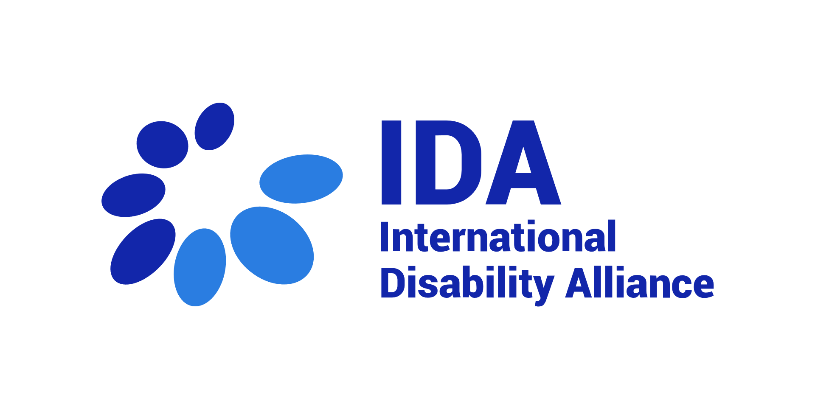

TERMS OF REFERENCE

Analysis of the knowledge architecture for disability-inclusive development and humanitarian action

April 2022

Table of Contents

About the International Disability Alliance (IDA) 3
Background and rationale 3
Objectives and services required 4
Management of the consultancies 5
Budget and payments 6
Profile sought and application process 6
Expertise required 6
Process for Interested Parties 7

About the International Disability Alliance (IDA)

We are an alliance of networks. IDA brings together over 1,100 organisations of persons with disabilities and their families from across eight global and six regional networks. Together we promote the rights of persons with disabilities across the United Nations' efforts to advance human rights and sustainable development. We support organisations of persons with disabilities to hold their governments to account and advocate for change locally, nationally and internationally. The cornerstone of our work is the United Nations Convention on the Rights of Persons with Disabilities (UN CRPD). We promote the effective and full implementation of the UN CRPD, and compliance by governments and the UN System, through the active and coordinated involvement of representative organisations of persons with disabilities at the national, regional and international levels. The 2030 Agenda and its Sustainable Development Goals are also integral to IDA's work to promote inclusive, sustainable development in line with the UN CRPD.
With member organisations around the world, IDA represents the estimated one billion people worldwide living with disabilities. This is the world’s largest – and most frequently overlooked – marginalised group. IDA, with its unique composition as a network of the foremost international disability rights organisations, is the most authoritative representation of persons with disabilities on the global level and acknowledged as such by the United Nations system both in New York and Geneva.
More information is available on www.internationaldisabilityalliance.org

Background and rationale
Over the past few years, the international humanitarian and development sectors have become much more aware of the need to embed disability inclusion in all programmes. This is due in large part to the successful advocacy of the international disability movement which, amongst other things, led to the 2015 Sustainable Development Goals including robust disability commitments. Subsequently the first Global Disability Summits in 2018 and 2022 have generated new commitments.
These commitments in turn generate an unprecedented growth in the demand for technical assistance and resources to ensure disability-inclusive policies and programmes. Donor governments, UN agencies, NGOs as well as other development and humanitarian actors are increasingly seeking outside support to design and deliver inclusive programmes and initiatives, where knowledge and expertise does not exist in-house. As progress is made in the understanding that rights-based disability-inclusive programming requires meaningful engagement with organisations of persons with disabilities (OPDs), OPDs – who have been deprioritized for long in development and humanitarian action – are confronted with stretched capacities to meet the demand and face strong opportunity costs.
Moreover, the learning architecture for disability-inclusive development and humanitarian action in line with the CRPD is currently disjointed and patchy, with many stand-alone online platforms and databases, few resources in available accessible formats, and lack of clear direction for all those interested in disability and implementation of the CRPD. Knowledge gaps are not easily identified, while existing resources are under-utilized.
Faced with this demand, the International Disability Alliance (IDA), working with Sightsavers, wishes to harness its convening role as a global representative alliance of OPDs to initiate a collaborative response through establishing an online disability knowledge platform. This platform would operate as a ‘one-stop-shop’, i.e. one central, accessible and curated website. The intention is that this will streamline and boost access to existing knowledge and resources, including documents, training modules, contacts of OPDs, signposting initiatives, and technical assistance/expertise (helpdesk function).
Ultimately this is expected to reduce ad hoc requests and avail to those that need it quality assured resources and knowledge which respects CRPD standards and available for all to use. This platform is also intended to act as a dynamic, user-friendly and accessible place to stimulate sharing of experiences and know-how among activists, other disability inclusion experts and external partners. By creating a ‘meta-platform’ that draws information from other existing platforms, this platform will not only avoid unnecessary duplication of content and large upfront costs, but it will also quickly bring a large corpus of knowledge onto one single platform.

Objectives and services required
To support the development of this disability knowledge platform, as an online environment that attracts contributors, stimulates exchanges and collaboration, and facilitate access to relevant resources, IDA is seeking support through 2 consultancies:
- A disability studies researcher with a wide knowledge of disability actors, networks and initiatives. The objective of the consultancy is to map existing platforms and initiatives producing disability knowledge and resources (including OPDs, INGOs, academia, UN, donor-led initiatives and others), their respective added value and contribution to the knowledge base on the rights of persons with disabilities.
Services required:
- Propose a detailed methodology for completion of the deliverables, including a proposed matrix for mapping of initiatives
- Identify and collect information on existing disability-related knowledge initiatives, including: knowledge platforms, websites, online resource repositories, collaborative initiatives aimed at generating evidence and know-how, academic disability studies portfolios, portals of experiences, etc. As a second priority, consultants are also expected to explore other non-disability focused initiatives or platforms that are “best in class” that we could also draw lessons from
- Screen and map existing initiatives, including their scope and objectives, and potential connections to expected objectives and functionalities of the collaborative disability knowledge platform (for example identifying where available: information on process for quality control/standards or criteria that exist for content; whether the systems are repositories or signposting to documents or other platforms or a combination of both; geographical scope covered; languages; accessible formats; strategies for moderation, updating, user engagement, project governance, sustainability and financing mechanisms; etc.)
- Present, discuss and integrate feedback from discussions with IDA, Sightsavers and other stakeholders (we envisage potential consultations with representatives of our audience, such as the UN, GLAD members, the IDDC consortium)
- Organize findings into a report including recommendations to IDA and Sightsavers
Expected deliverables:
- Inception report with detailed proposed methodology
- Map of disability knowledge initiatives
- Final report and ppt format presenting key findings and recommendations

- An experienced specialist in web-based knowledge platforms and online community of practices. The objective of the consultancy is to carry out a benchmarking of existing online knowledge management platforms and relevant functionalities (within and beyond the disability sector), including accessible features, and requirements for interoperability with the IDA online ecosystem, and to provide technical (IT) recommendations for the development of the future platform and its functions, including but not limited to an online searchable resource repository, an embedded interactive online OPD map (already in progress), a helpdesk query tool.
The 2nd consultancy is advertised separately, please see on the IDA website for more information: https://www.internationaldisabilityalliance.org/content/opportunities .

Applicants are expected to demonstrate how they will ensure that reports, methods, approaches, and tools are fully inclusive of and accessible to all groups of persons with disabilities. The exact methodologies and tools to address will be determined through discussion between the consultant(s) and IDA at the beginning of the assignment.

Management of the consultancies
This work is commissioned by IDA, in partnership with Sightsavers. Overall, the consultant’s final report will inform the development of this joint project, which is meant to be initiated by IDA with the support Sightsavers, but to develop as a collaborative initiative.
The contact person is: Priscille Geiser, Program Director, pgeiser@ida-secretariat.org

The consultancy will run for a minimum of 18 working days from the moment of the signature of the contract to 31st July, 2022 (or as agreed between IDA and the selected applicant). The selected consultant is expected to begin the assignment as soon as possible.

Budget and payments
The maximum budget for the evaluation is 15,000 USD, including VAT. Any potential missions costs, if any, will be covered separately by IDA.

Payments are structured as follows:
Milestone | Payment share
Signature of the contract | 50 %
End of the assignment | 50%

This is a short-term contract with a partial to full commitment based on the research requirements.

Profile sought and application process

Expertise required
Candidates must comply with the following minimum requirements:
- Masters’ degree in a field relevant to the scope of the consultancy, e.g. disability studies, international development, human rights
- At least 7 years of or equivalent experience in disability research, disability-inclusive international cooperation
- Extensive network and knowledge of disability stakeholders, including disability research
- Prior experience in leading research projects involving mapping, evidence review, knowledge management and organization of resources
- Familiarity with online information management systems, including information flow, resource architecture and effective functionalities for online knowledge management and sharing
- Full proficiency in oral and written English, with ability to produce quality analytical reports in English with limited editorial oversight
- Knowledge of additional UN official languages would be a strong asset

Process for Interested Parties
Interested parties shall submit:
- Curriculum/a Vitae.
- a proposal describing the previous work done in this area
- All pieces of evidence to demonstrate the compliance with the minimum requirements and additional assessment criteria listed above.
- A signed financial offer.
All documents shall be submitted in English by email only to tenders@ida-secretariat.org. The email should have the following subject “Application Knowledge Architecture”.
Submission deadline: 28th May 2022
All inquiries on the selection process shall be submitted to the same email address.

