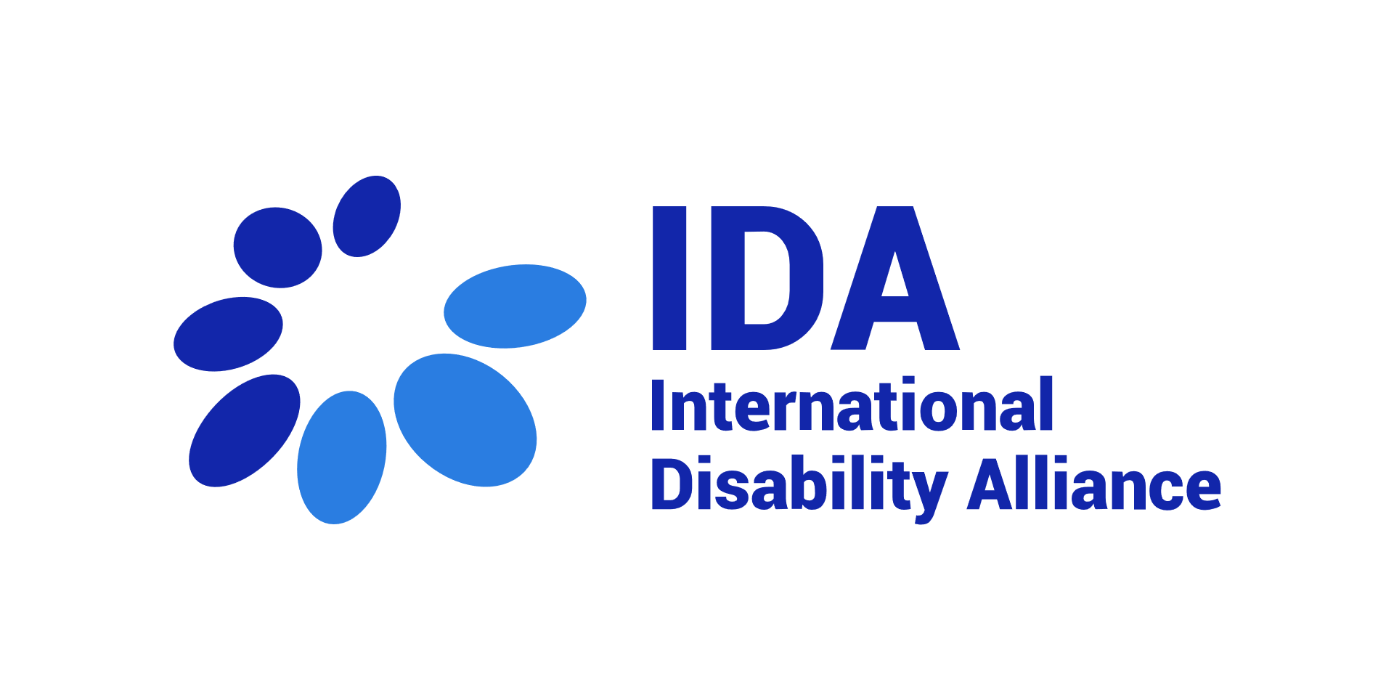

TERMS OF REFERENCE

Benchmarking and recommendations for accessible IT structure and functionalities for an online knowledge platform

APRIL 2022

Table of Contents

About the International Disability Alliance (IDA) 3
Background and rationale 3
Objectives and services required 4
Management of the consultancies 6
Budget and payments 6
Profile sought and application process 6
Expertise required 7
Process for Interested Parties 7

About the International Disability Alliance (IDA)

We are an alliance of networks. IDA brings together over 1,100 organisations of persons with disabilities and their families from across eight global and six regional networks. Together we promote the rights of persons with disabilities across the United Nations' efforts to advance human rights and sustainable development. We support organisations of persons with disabilities to hold their governments to account and advocate for change locally, nationally and internationally. The cornerstone of our work is the United Nations Convention on the Rights of Persons with Disabilities (UN CRPD). We promote the effective and full implementation of the UN CRPD, and compliance by governments and the UN System, through the active and coordinated involvement of representative organisations of persons with disabilities at the national, regional and international levels. The 2030 Agenda and its Sustainable Development Goals are also integral to IDA's work to promote inclusive, sustainable development in line with the UN CRPD.
With member organisations around the world, IDA represents the estimated one billion people worldwide living with disabilities. This is the world’s largest – and most frequently overlooked – marginalised group. IDA, with its unique composition as a network of the foremost international disability rights organisations, is the most authoritative representation of persons with disabilities on the global level and acknowledged as such by the United Nations system both in New York and Geneva.
More information is available on www.internationaldisabilityalliance.org

Background and rationale
Over the past few years, the international humanitarian and development sectors have become much more aware of the need to embed disability inclusion in all programmes. This is due in large part to the successful advocacy of the international disability movement which, amongst other things, led to the 2015 Sustainable Development Goals including robust disability commitments. Subsequently the first Global Disability Summits in 2018 and 2022 have generated new commitments.
These commitments in turn generate an unprecedented growth in the demand for technical assistance and resources to ensure disability-inclusive policies and programmes. Donor governments, UN agencies, NGOs as well as other development and humanitarian actors are increasingly seeking outside support to design and deliver inclusive programmes and initiatives, where knowledge and expertise does not exist in-house. As progress is made in the understanding that rights-based disability-inclusive programming requires meaningful engagement with organisations of persons with disabilities (OPDs), OPDs – who have been deprioritized for long in development and humanitarian action – are confronted with stretched capacities to meet the demand and face strong opportunity costs.
Moreover, the learning architecture for disability-inclusive development and humanitarian action in line with the CRPD is currently disjointed and patchy, with many stand-alone online platforms and databases, few resources in available accessible formats, and lack of clear direction for all those interested in disability and implementation of the CRPD. Knowledge gaps are not easily identified, while existing resources are under-utilized.
Faced with this demand, the International Disability Alliance (IDA), working with Sightsavers, wishes to harness its convening role as a global representative alliance of OPDs to initiate a collaborative response through establishing an online disability knowledge platform. This platform would operate as a ‘one-stop-shop’, i.e. one central, accessible and curated website. The intention is that this will streamline and boost access to existing knowledge and resources, including documents, training modules, contacts of OPDs, signposting initiatives, and technical assistance/expertise (helpdesk function).
Ultimately this is expected to reduce ad hoc requests and avail to those that need it quality assured resources and knowledge which respects CRPD standards and available for all to use. This platform is also intended to act as a dynamic, user-friendly and accessible place to stimulate sharing of experiences and know-how among activists, other disability inclusion experts and external partners. By creating a ‘meta-platform’ that draws information from other existing platforms, this platform will not only avoid unnecessary duplication of content and large upfront costs, but it will also quickly bring a large corpus of knowledge onto one single platform.

Objectives and services required
To support the development of this disability knowledge platform, as an online environment that attracts contributors, stimulates exchanges and collaboration, and facilitate access to relevant resources, IDA is seeking support through 2 consultancies:

- An experienced specialist in web-based knowledge platforms and online community of practices. The objective of the consultancy is to carry out a benchmarking of existing online knowledge management platforms and relevant functionalities (within and beyond the disability sector), including accessible features, and requirements for interoperability with the IDA online ecosystem, and to provide technical (IT) recommendations for the development of the future platform and its functions, including but not limited to an online searchable resource repository, an embedded interactive online OPD map (already in progress), a helpdesk query tool.
Services required:
- Propose a detailed methodology for completion of the deliverables
- Identify relevant online IT functions that could support the objectives of the disability knowledge platform and search examples on existing online platforms, covering:
  - Typical and innovative functions for user interaction and engagement (e.g. blog, ability to create a personal profile; customizable registration system where base information can be captured when a user registers (e.g. region, stakeholder group, key interests, etc.; weekly digest)
  - Online resource repositories (e.g. tagging systems/ naming conventions, search engines, process for content upload…)
  - Embedding existing apps/ functions into the website (e.g. online interactive map, integrated access and visibility of relevant social media platforms, integration with Google analytics, Google translate)
  - Gateway to other platforms to provide quick and easy access to partner organisations’ websites for access to further resources
  - System for single web posting process redirecting to multiple sites (e.g. IDA website or disability knowledge platform)
  - Online helpdesk query/ ticketing system and inclusion of a ‘roster of experts’, which will make it possible for users to contact worldwide development co-operation experts.
- In relation to the objectives of the platform, provide recommendations on:
  - A possible architecture/ structure of the platform
  - IT functions and options, including accessibility requirements
  - Tentative costing
  - Formulation of technical requirements for procurement
Expected deliverables:
- Inception report with detailed proposed methodology
- Review of potential functions responding to objectives of the platform, including examples
- Recommendations for possible architecture, accessible IT solutions and functions, and tentative costing
- Draft Terms of Reference to procure services for building the platform
Please note: We envisage that additional days might be requested to develop an advanced mock version of the platform, after a review of deliverables a to d. Interested applicants are also invited to include this in their technical proposal, with an estimated extra cost (beyond the maximum budget indicated below).

- A disability studies researcher with a wide knowledge of disability actors, networks and initiatives. The objective of the consultancy is to map existing platforms and initiatives producing disability knowledge and resources (including OPDs, INGOs, academia, UN, donor-led initiatives and others), their respective added value and contribution to the knowledge base on the rights of persons with disabilities.
This consultancy is advertised separately, please see on the IDA website for more information: https://www.internationaldisabilityalliance.org/content/opportunities .

Applicants are expected to demonstrate how they will ensure that reports, methods, approaches, and tools are fully inclusive of and accessible to all groups of persons with disabilities. The exact methodologies and tools to address will be determined through discussion between the consultant(s) and IDA at the beginning of the assignment.

Management of the consultancies
This work is commissioned by IDA, in partnership with Sightsavers. Overall, the consultant’s final report will inform the development of this joint project, which is meant to be initiated by IDA with the support Sightsavers, but to develop as a collaborative initiative.
The contact person is: Priscille Geiser, Program Director, pgeiser@ida-secretariat.org
The consultancy will run for a maximum of 18 working days from the moment of the signature of the contract to 31st July, 2022 (or as agreed between IDA and the selected applicant). The selected consultant is expected to begin the assignment as soon as possible.

Budget and payments
The maximum budget for the evaluation is 15,000 USD, including VAT. Any potential missions costs, if any, will be covered separately by IDA.

Payments are structured as follows:
Milestone | Payment share
Signature of the contract | 50 %
End of the assignment | 50%

This is a short-term contract with a partial to full commitment based on the research requirements.

Profile sought and application process

Expertise required
- At least 7 years of prior experience designing visually appealing and navigation-friendly web sites;
- Broad knowledge of current web development technologies and design in the field, and new software and other web programming languages and programs including use of HTML, XHTML, CSS, XML, XSLT, Macromedia Flash, Java
- Demonstrated experience in ICT accessibility
- Familiarity and relevant experience in using different Content Management Systems (CMS)

Process for Interested Parties
Interested parties shall submit:
- Curriculum/a Vitae.
- a proposal describing the previous work done in this area
- All pieces of evidence to demonstrate the compliance with the minimum requirements and additional assessment criteria listed above.
- A signed financial offer.
All documents shall be submitted in English by email only to tenders@ida-secretariat.org. The email should have the following subject “Application Benchmarking IT platform”.
Submission deadline: 28th May 2022
All inquiries on the selection process shall be submitted to the same email address.

