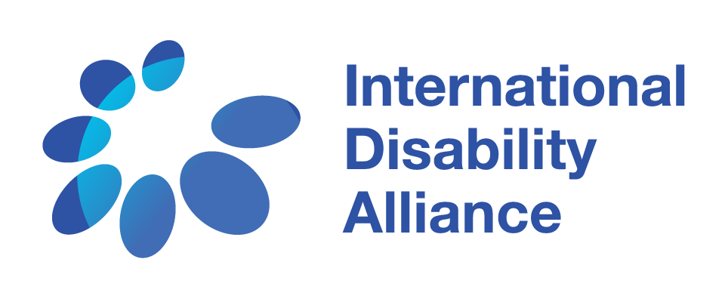

Terms of reference

Technical paper on Universal Design for Learning as a key determinant for achieving SDG 4 for all learners, including learners with disabilities

Summary
The International Disability Alliance (IDA) seeks support from experienced researchers to develop a technical paper on the potential of Universal Design for Learning (UDL) in supporting the realisation of Sustainable Development Goal (SDG) 4 for all learners, including learners with disabilities. This paper will build on the IDA technical consensus position on the implementation of SDG 4 in line with Article 24 of the UN Convention on the Rights of Persons with Disabilities (CRPD) and the IDA Global Report on Inclusive Education (2020).
The objective of the technical paper is to review the potential of UDL from a range of perspectives including different disability groups, region, socio-economic conditions, etc. in the context of the IDA consensus position. The paper is intended to provide evidence that will help develop guidance for OPDs particularly at the national and local level to better articulate how to create a truly inclusive, equitable and quality education system for all learners including those with disabilities.

This technical paper is part of a series of papers and case studies that IDA, led by the IDA Inclusive Education Task Team, will undertake to enhance IDA’s technical consensus position on SDG 4 and Article 24 and the subsequent IDA Global Report on Inclusive Education, as well as demonstrate operational models to implement this vision.

About IDA
The International Disability Alliance (IDA) was established in 1999 and is a network of eight global—and, six regional organisations of persons with disabilities (OPDs), representing the voice of the estimated one billion persons with disabilities worldwide. IDA is a network representing members that are organisations of persons with disabilities. IDA’s unique composition as a network of international OPDs allows it to act as an authoritative and representative voice of persons with disabilities in the United Nations (UN) system, both in New York and Geneva. IDA’s mission is “To advance the human rights of persons with disabilities, as a united voice of organizations of persons with disabilities, utilizing the Convention on the Rights of Persons with Disabilities and other human rights instruments”. IDA’s longer-term goal is that “the United Nations framework (the General Assembly, Security and Human Rights Councils, treaty bodies and development agencies), bilateral and multilateral development agencies, regional organizations and human rights instruments contribute to create an enabling environment for OPD advocacy and government capacity to implement the UN CRPD at national level”.

Background
In the education sector, explicit references to persons with disabilities in the SDGs provided opportunities to explore connections and mutual reinforcements between SDG 4 and CRPD Article 24. The adoption of the General Comment on the “right to inclusive education” by the Committee on the Rights of Persons with Disabilities has been a landmark providing clarity on interpretation of rights and states obligations under Article 24 of the CRPD. However, there was a lack of clear understanding or vision as to what it means to implement SDG 4 in line with the CRPD. It was to address this gap that IDA, through its Inclusive Education Flagship Initiative, developed an OPD-led, consensus position on implementation of the SDG 4 for all learners, including learners with disabilities. Led by the IDA Inclusive Education Task Team, IDA built on this consensus position to publish the first IDA Global Report on Inclusive Education which further elaborated on this position and also highlighted the minimum conditions that are needed to be met to implement SDG 4 for everyone, including learners with disabilities by 2030. The next step in IDA’s work on inclusive education is to strengthen the technical position with more in-depth elaboration of some of the critical elements that are essential to have a truly inclusive environment. The objective is to show operational models of how to implement SDG 4 in line with the CRPD as well as to also document what has worked including policy scenarios that comply with the standards of the CRPD for all groups, and adjust to the cultural, social and economic realities of low and middle-income countries. The larger goal is to get greater clarity within the disability movement and among OPDs on an approach to education that fully respects the CRPD. This clarity is important to ensure that in a context of competing priorities and limited funding, OPDs come up with clear messages and recommendations, building on the evidence of what works and looking at mechanisms for taking good practices to scale for broader impact.

Purpose and intended use of the technical paper on Universal Design for Learning (UDL) and inclusive education
The purpose of the consultancy is to collect, review and analyse information on how UDL addresses the diversity of needs among learners, how it is being implemented in education systems including the gaps; highlight good practices and understand if and how investing in UDL would support in achieving the vision for inclusive, equitable, quality education for all learners including learner with disabilities; and provide recommendations for governments, civil society including OPDs and other actors in the education space.

This technical paper will be one in a series of case studies and other technical papers that IDA will undertake in order to further illustrate its vision for implementing SDG 4 for all learners by 2030 in keeping with the Convention of the Rights of Persons with Disabilities. The objective of this paper is to explain some of the critical elements that are a precondition for inclusive education and provide an operational model of how some of these can be implemented within education sector planning and programming. The technical paper will include national perspectives particularly from global South countries.

Some of the issues that paper will address include, but not limited to, are as follows
- What is UDL and its key contribution to inclusive education?
- UDL in the framework of the IDA technical position on Article 24 and the UNESCO GEM Report 2020
- How does UDL take into account the diversity of needs and priorities within the student population, including learners with disabilities? Include examples of how UDL responds to diverse requirements from diverse learners with disabilities, including underrepresented groups.
- Are there good examples of legal frameworks, policies or standards governing UDL in education, including at the national and local level? Are there examples of relevant provisions under current education laws, policies and regulations supporting UDL as a key driver of inclusive education?
- According to lessons learnt, what have been the obstacles and facilitators of reform towards the use of UDL? What are the prerequisite if any, for implementing UDL?
- What are examples from Global South countries, including from the perspective of different disability communities particularly those from under-represented groups.
- What have been the critics and support among stakeholders involved in UDL reform at local and/or national level?
- What are some of the current impediments towards implementing UDL in education sector?
- Cross-sectoral approach and budget allocation on UDL
- UDL in relation to curriculum development, teacher training, accessibility, accommodation and individualized support, education sector planning, among others

Consultant tasks
- Identify available evidence, including but not limited to some of the issues highlighted above, from existing data sources (literature review, including published and grey literature, official data and statistics, administrative data, case studies, etc.)
- Collect case studies/ examples from a diverse perspective of needs, geographical location, types of marginalization, etc. through review of existing evidence as well as key informant interviews and focus group discussions
- Compile and organize the available evidence into a folder of resources to be shared with the IDA Inclusive Education Task Team
- Compile all data into a report that illustrates the current landscape of UDL, the gaps between the current status and the vision, and make recommendations for different stakeholders
- Present the report to the IDA Inclusive Education Task Team

Deliverables
- A short document (1-2 pages max) describing the methodology to be used for the technical paper (1 week to 10 days after the start of the consultancy). This should include a proposed outline of the paper.
- A database with all evidence collected, organized as agreed at the beginning of the consultancy in the above methodology document
- A narrative report (first draft by April 30, final version by the May 31, 2021)
- A power point presentation to be presented to the IDA Inclusive Education Task Team (no later than the June 7, 2021)
- A summary document (1-2 pages) for external communication
- Any additional deliverables that are agreed at the beginning of the consultancy (in the above methodology document)

Timeline
The consultancy needs to be completed between March and end May 2021. A first draft report should be sent no later than April 30, 2021, and the PowerPoint presentation should be ready no later than June 7, 2021.

Qualifications
- Relevant university degree in education, disability studies, and/or public policy
- Strong research experience and knowledge of data management and analysis
- Proven experience and expertise on education sector reform, including education for learners with disabilities
- Understanding of Universal Design for Learning and its application in education sector planning and programming
- Understanding the challenges and issues faced by different disability sectors
- Demonstrated interest and familiarity with the rights of persons with disabilities, especially inclusive education, CRPD Article 24 and related jurisprudence
- Ability to write a concise and analytical research report in English
- Excellent written skills

Budget
- Applicants are invited to submit a budget/quotation within their proposal. The expected total budget will range from 5,000 to 7,000 US Dollars.
- Applicants are invited to detail additional expenses needed to deliver the tasks. Those additional expenses will be evaluated by IDA selection committee. Any travel costs, or accessibility costs for webinars, will be taken care of by IDA as per IDA travel policy.

Contracting and Remuneration
- A consultancy contract (as per Swiss law) will be signed between the selected consultant(s) and IDA.
- Applicants are invited to submit a copy of their passport and commercial/consultant registration/tax numbers. Only applicants with valid commercial and/or consultant registration and/or tax numbers will be considered.
- Payments will be made in several installments and upon successful completion of the deliverables and submission of invoices.

Please send a letter of interest and a detailed proposal (with budget/quotation) to consultancy@ida-secretariat.org latest by March 1, 2021 by 5 PM EST.
Note: The subject line of the e-mail should be “Application for IE Technical Paper Consultancy”.

