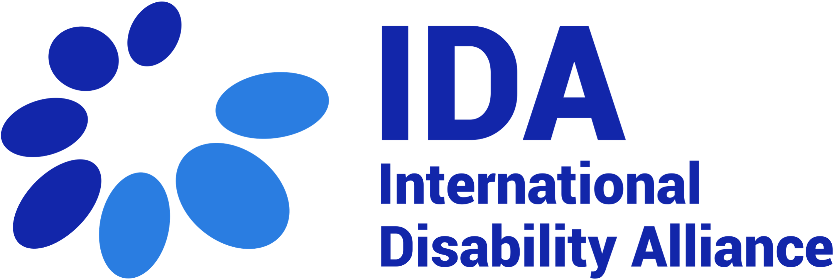
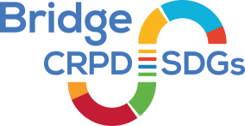

Bridge CRPD-SDGs Training of Trainers
Curriculum Validation Workshop
List of participants

Participants
- Ms. Martine Abel Williamson, World Blind Union, New Zealand
- Ms. Betty Najjemba, African Disability Forum, Uganda
- Mr. Siddo Nouhou Oumarou, West African Federation of OPDs, Niger
- Ms. Christine Kirungi, Uganda
- Ms. Dorothy Nakato, World Network of Users and Survivors of Psychiatry, Uganda
- Ms. Bhargavi Venkatasubramaniam, Transforming Communities for Inclusion, India
- Mr. Waqar Puri Shahid, Transforming Communities for Inclusion, Pakistan
- Ms. Jenipher Akinyi, Inclusion Africa, Kenya
- Ms. Fatma Wangare Haji, Inclusion Africa, Kenya
- Mr. Hassan Zilakulabe, Inclusion Africa, Uganda
- Ms. Miheret Niguisse, Inclusion Africa, Ethiopia
- Ms. Carolyn Dagani, Philippines
- Mr. Katabwena Tawaka, Pacific Disability Forum, Fiji
- Ms. Savaira Tinaiunivalu, Pacific Disability Forum, Fiji
- Ms. Faatino Utumapu, Pacific Disability Forum, Samoa
- Mr. Alexandre Bloxs, World Disability Forum, Belgium
- Ms. Shitaye Astaves, African Disability Forum, Ethiopia
- Ms. Rokiatu Diakite, Mali
- Ms. Agnes Abukito, World Federation of the Deafblind, Uganda
- Ms. Juliet Wabukawo, World Federation of the Deafblind, Uganda
- Mr. Moses Serwadda, International Federation of the Hard of Hearing, Uganda
- Ms. Ekaete Judith Umoh, CBM Global, Nigeria
- Ms. Ina Lykke Jensen, DPOD, Denmark
- Ms. Irene Mulunda, HI, Kenya
- Ms. Jane Waithera, Light for the World, Kenya
- Mr. Mark Mapemba, Inclusion Africa, Malawi

Facilitators
- Ms. Tchaurea Fleury, France
- Ms. Amba Salelkar, India
- Ms. Dorodi Sharma, India
- Ms. Rosario Galarza, Peru
- Mr. Imed Ouertani, Tunisia
- Mr. Rejaul Karim Sidiqueee, Bangladesh
- Ms. Elizabeth Ombati, Kenya

Support Persons

- Ms. Haydee Hinojosa, Personal Assistant, Peru
- Ms. Chedlia Ouertani, Personal Assistant, Tunisia
- Ms. Hope Agwang, Ugandan Sign Language Interpreter, Uganda
- Ms. Aichatou Oumarou Siddo, Personal Assistant, Niger
- Mr. Emmanuel Wasswa, Personal Assistant, Uganda
- Ms. Jasmine Ochieng, Personal Assistant, Kenya
- Ms. Natasha Maliko, International Sign interpreter, South Africa
- Mr. Samuel Chew, International Sign Interpreter, Malaysia
- Ms. Tigist Astaves, Personal Assistant, Ethiopia
- Mr. Mory Diakite, Personal Assistant, Mali
- Mr. Gabriel Onyango, Voice Over Assistant, Uganda
- Ms. Rose Bulime Nakazibve, Guide Interpreter, Uganda
- Ms. Miriam Nambi, Guide Interpreter, Uganda
- Mr. Jonathan Ndawula, Captioner, Uganda
- Ms. Eno Sandra Uyebi, Personal Assistant, Nigeria
- Ms. Precious Kanjuchi, Personal Assistant, Malawi
- Ms. Sarah Ibasirika, Personal Assistant, Uganda

Logistics, Finance and Communication
- Ms. Dragana Jocic, Logistics Manager
- Ms. Marija Parojic, Logistics Assistant
- Ms. Marija Rankovic, Logistics Assistant
- Ms. Audrey Bernard-Granger, Finance
- Ms. Karen D’Dimpsaar, Communications Consultant

