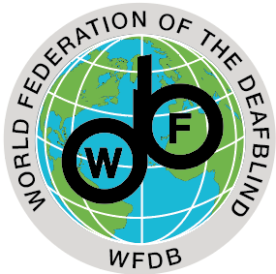

Persons with deafblindness and inequalities:
What the data say, what the reality is, and the road ahead.

2018 Global monitoring report on situation and rights of Persons with Deafblindness

20th Session of the CRPD committee
14th September 2018 13.30-15.00, in Geneva, Palais des Nations Room XVII

The side event hosted by the World Federation of the Deafblind (WFDB) aims to share with the CRPD committee member and members of the Human Rights council, the key findings and recommendations of the initial global monitoring report on situation of persons with deafblindness.
Representing between 0.2% to 2% of the population, persons with deafblindness are a diverse group and are overall more likely to be poor and unemployed, and with lower educational outcomes than other people with disabilities. They face multiple barriers such as severe lack of access to support services and accessible information, which ultimately make it very difficult to voice their issues. Moreover, the fact that persons with deafblindness are rarely recognised as distinct disability group has contributed to persistent invisibility leading to lack of support and services.
Combining the largest population-based analysis of persons with deafblindness conducted to date (disaggregation of more than 20 population-based surveys from low, middle and high-income countries), a review of academic literature, two surveys conducted among members and partners of WFDB and Sense International, as well as case studies, the report covers the diversity of persons with deafblindness, their lived experiences, the barriers and inequalities they face. It also seeks to propose very concrete recommendations to Members States, development agencies and civil society organizations.
Women and men with deafblindness from across the world took part in the Helen Keller World Conference in June 2018, and were consulted to confirm the findings and elaborate on the recommendations from this report.

Side event program:
- Opening remarks:
  - Catalina Devandas Aguilar, Special Rapporteur on the Rights of Persons with Disabilities
- Why a global report?
  - Geir Jensen, President WFDB, Norway.
- Lessons learned from disaggregating 20 national data sets including persons with deafblindness.
  - Morgon Banks/Islay Mac Taggart , ICED, London School of Hygiene and Tropical Medicine, UK
- What does inclusion mean for persons with Deafblindness?
  - Agnes Abukito, WFDB, Uganda (video).
- Perspective from Asia
  - Lauro Purcil, Convenor of the Philippines CRPD coalition, Board member of Asean Disability Forum, Member of WFDB
- Key recommendations to include persons with Deafblindness in disability rights and inclusive development programs.
  - Rune Jensen, Editing Consultant WFDB, Norway.

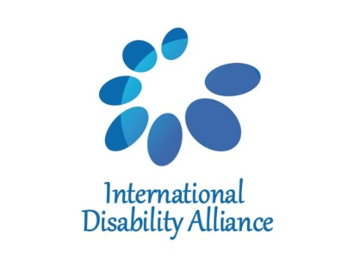
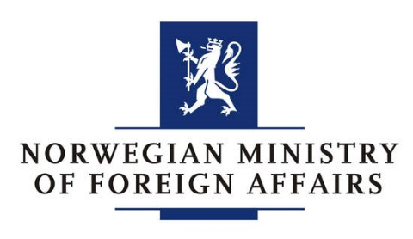
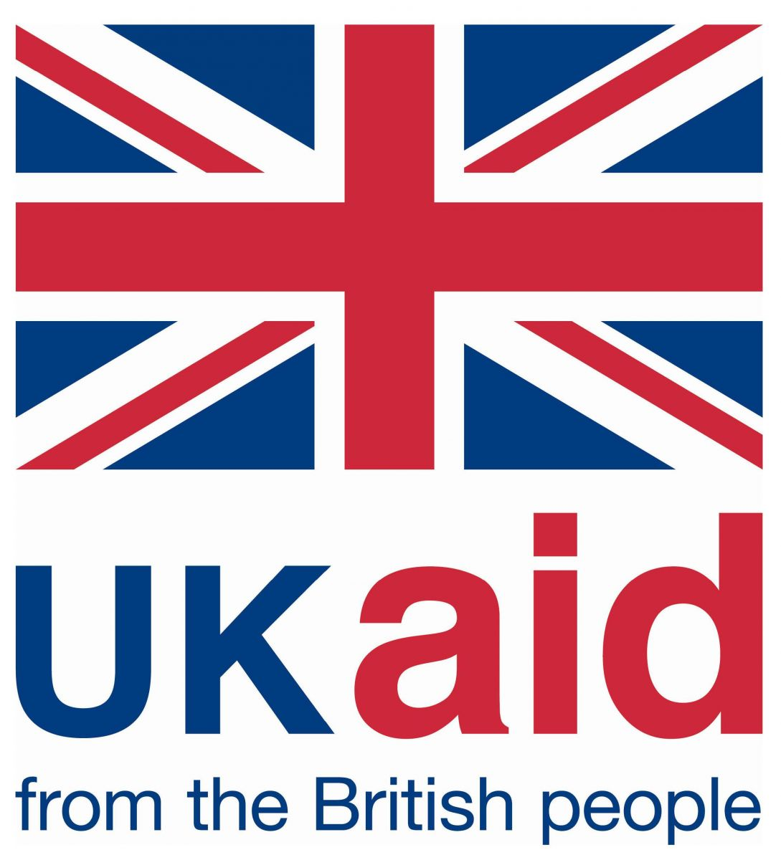
In cooperation with: With the financial support of:

