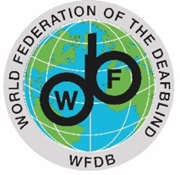
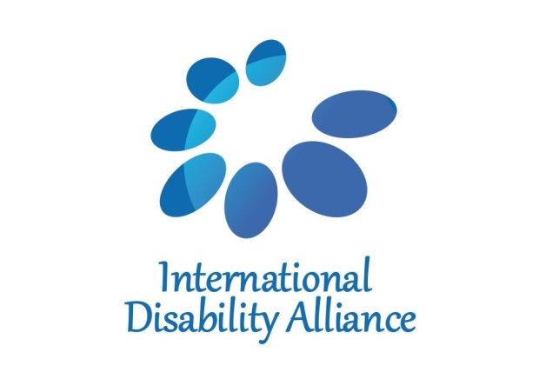

TERMS OF REFERENCE FOR RESEARCH CONSULTANT

INTERNATIONAL DISABILITY ALLIANCE (IDA) AND THE WORLD FEDERATION OF THE DEAFBLIND (WFDB)
The International Disability Alliance (IDA) was established in 1999 as a network of global and, since 2007, regional disabled people’s organizations (DPOs).
The aim of IDA is to promote the effective and full implementation of the UN Convention on the Rights of Persons with Disabilities (CRPD) worldwide, as well as compliance with the CRPD within the UN system, through the active and coordinated involvement of representative organizations of persons with disabilities at national, regional and international levels.
With member organizations around the world, IDA represents the estimated one billion people worldwide living with a disability. This is the world’s largest – and most frequently overlooked – minority group. IDA, with its unique composition as a network of the foremost international disability rights organizations, is the most authoritative representative voice of persons with disabilities and acknowledged as such by the United Nations system both in New York and Geneva.
The World Federation of DeafBlind (WFDB) is a global nongovernmental advocacy organization by and for persons with deafblindness.

Consisting of 75 national and associated deafblind organizations from 62 different countries in all parts of the world, WFDB is recognized as the official and legitimate global voice of persons with deafblindness.

WFDB aims to improve the quality of life for persons with deafblindness worldwide; Focusing on achieving equal rights and equal opportunities in all areas of society; to be a forum for exchanging knowledge and experiences regarding deafblindness and to promote international solidarity among organizations by and for people with deafblindness through cooperation, organizational development, capacity building and advocacy, among others.

BACKGROUND OF THE MISSION
Building upon the findings of its First Global Report on Deafblindness developed in 2018, WFDB aims to develop a second version of the report. As the first Global Report identified major issues to resolve for the inclusion of persons with deafblindness in the implementation of core human rights, the CRPD and the Sustainable Development Goals, there is still a need to identify best practices to guide the way forward. In other words, while the First Global Report shed light on the situation of persons with deafblindness and reflected their priorities, the 2nd Global report will provide evidence and case studies to respond to these priorities.

The 2nd Global report will be critical to strengthen the common ground and understanding achieved with the first report, across regional and global disability, development and human rights stakeholders. It will also serve as an advocacy tool for WFDB members at national and regional levels.

WFDB will use the development process of the report to further mobilise both WFDB members, their allies, as well as UN agencies. The process will be fully consultative, including a survey and focus group discussions, to ensure strong ownership and involvement of WFDB members. An expert meeting will also be organized in Geneva both to mobilise and to gather contributions of different NGOs and UN agencies including (but not limited to) WHO, OHCHR, ILO, UNICEF and the Special Rapporteur on the rights of persons with disabilities.

To ensure continuity with the first report and consistency of data, WFDB will hire a consultant to kick start the process through the consolidation and expansion of data analysis of the 22 countries population survey datasets considered in the first report and of 3 additional ones.

SERVICE DESCRIPTION

General information
Secondment contract: No
Duration: maximum of 10 working days
Renumeration: € 6,000

Main tasks

- Integration of the previous data collection with and updated quantitative analysis of the datasets from census surveys of the 22 countries considered in the first report.
- Consolidate the quantitative analysis incorporating data from additional countries:
Disaggregation of 3 London School of Hygiene & Tropical Medicine data sets (Cameroon, Guatemala and India) to explore the magnitude of vision and hearing functional limitations (non-compensatory loss in both senses) in all-age population, including:
  - Prevalence from birth versus acquired
  - Age and sex distribution
  - Functional distribution (i.e., severity of respective limitations)
  - The Lived Experience of deafblindness
    - Access to work, school, health care
    - Participation and the environment
    - Poverty

Deliverables
- Secondary Dataset Analysis
- Analysis Write Up

Requirements
- Strong academic research background (PHD) with strong skills in quantitative methods
- Active research on the situation of persons with disabilities with an international development perspective
- Knowledge on Human Rights and persons with disabilities
- Excellent writing skills including Academic English proficiency
- Prior experience relating to persons with deafblindness would be a strong bonu

TO APPLY
Interested candidates shall send, alongside their CVs, a proposition of the estimated working days to complete the tasks, for a maximum of 10 working days by email to consultancy@ida-secretariat.org by 01 March 2021, indicating the subject line: “WFDB Application: Research Consultant”. Applications received after this date will not be considered.

Note: Only completed application forms will be accepted. Please be advised that only shortlisted applicants will be informed about the next steps of selection process. Persons with disabilities are strongly encouraged to apply.

Confidentiality: All information given on the application will be treated in a confidential manner.

