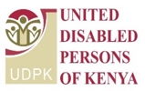
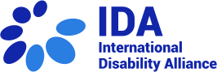
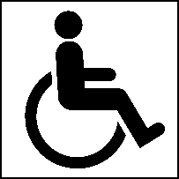
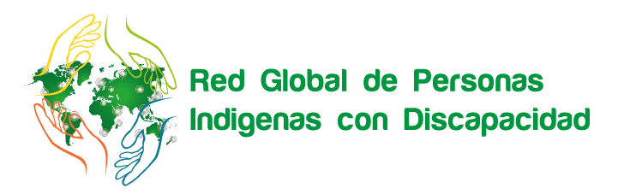

NAROK SOUTH DISABILITY NETWORK

Indigenous Persons with Disabilities Global Network

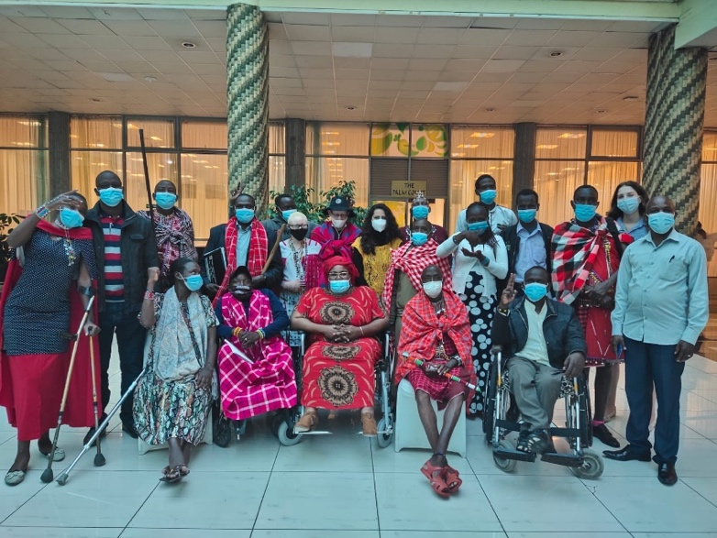

Technical Workshop on ensuring the rights of Indigenous Persons with Disabilities in line with UNCRPD, in connection with the UNDRIP, the Agenda 2030 and GDS consultation
Workshop report

21 to 23 June 2021
Nairobi, Kenya

in connection with the UN DRIP and the Agenda 2030

www.internationaldisabilityalliance.org/technical-workshop-kenya-june2021
Background
From 21 to 23 June, the Indigenous Persons with Disabilities Global Network (IPWDGN), the Narok South Disability Network and the International Disability Alliance (IDA) had hosted the Workshop on Ensuring the rights of indigenous persons with disabilities in line with UNCRPD, in connection with the UN Declaration on the Rights of Indigenous People (DRIP), the Agenda 2030, as well as a day of consultation on commitments made during the Global Disability Summit 2018.
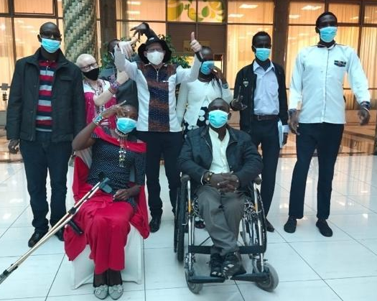
The workshop took place in Nairobi, Kenya, and was attended by representatives of organizations of indigenous persons with disabilities (IDPOs) from different counties such as Narok, Kajiado, Baringo and Samburu; and different constituencies, and included indigenous persons with psychosocial disabilities, albinism, persons with small stature and Deaf people.
During the three-day workshop, participants got exposure to the Convention on the Rights of Persons with Disabilities (CRPD), Sustainable Development Goals (SDGs), and the United Nations Declaration on the Rights of Indigenous Peoples (UNDRIP). Furthermore, they reviewed the commitments made during the Global Disability Summit (GDS) by the Kenyan Government and key stakeholders working in Kenya. They also analyzed the implementation of those commitments to the indigenous peoples in Kenya. The main goals of this workshop were to strengthen the capacity of the indigenous peoples with disabilities group in Kenya on the CRPD, UNDRIP and SDGs as well as to understand how the COVID-19 crisis has affected indigenous peoples with disability and their representative organizations.

First day
21 June 2020
Manase Ntutu, Co-Chair of the IPWDGN opened the technical workshop highlighting that “(T)he IPWDGN is working together with IDA on training and educating regional and national organizations of indigenous persons with disabilities, to be in line with UNDRIP and the CRPD. It is important for us to learn about our rights, to be empowered, to be leaders, and to know that we have support.”
The workshop was co-facilitated by Manase Ntutu (Kenya), Alradi Abdalla (Bridge CRPD-SDGs ToT Officer, Sudan), Peter Ochieng (Youth Fellow, Uganda), Agnes Abukito (Gender Fellow IDA-WFDB, Uganda), and Kato Mark (Youth Fellow IDA-WFDB, Uganda). Distant support was provided by Amba Salelkar (Bridge CRPD-SDGs ToT Officer, India), Rosario Galarza (Intersectionalities Officer, Peru), and Mirriam Nthenge (Technical Support Officer, Kenya). This group of facilitators brought different local, national, regional, and global perspectives of human rights and development, embracing, at the same time, the diversity of persons with disabilities and indigenous peoples.
The day started with the introduction of the facilitators and participants. Then participants shared some of their expectations from this workshop, which are the following:
- To learn more about CRPD and how it is related to the rights of indigenous people,
- Networking, making new friends, and learning about different organizations and how to work together with indigenous people,
- Understanding how the COVID-19 crisis has affected indigenous people with disability, organizations and each one of the present participants,
- Knowing more about International Disability Alliance (IDA) and how individual organizations can connect with IDA and get more information.
This was followed by a brief introduction to the Convention on the Rights of persons with Disabilities (CRPD), its meaning and objective, the principles, and its practical understanding. Then participants discussed the Declaration on the Rights of Indigenous Peoples (UNDRIP), as well as its content and history.
Further, they were introduced to three (03) global monitoring mechanisms: the UN Special Rapporteur on the Rights of Indigenous Peoples, Expert Mechanism on the Rights of Indigenous Peoples (EMRIP) and the UN Permanent Forum on Indigenous Issues.
The day ended with a very positive evaluation from the participant team that shared feedback from the participants. They found the training useful and critical to strengthen their understanding on, and make linkages between, the CRPD and the UNDRIP.

Second day
22 June 2020
The second day of the workshop started with recapping the CRPD and General Principles of the Convention that were discussed previously with the group. The main points that were covered were rights of making decisions on an individual level, and identifying barriers that people with disability and indigenous people with disability are facing on daily basis, such as non-discrimination, diversity, and inequality, among others. The conclusion was that when we are talking about disability and raising awareness, the core values are the CRPD Principles.
The group then worked on case studies discussing linkages between the CRPD and the Declaration on the Rights of Indigenous Peoples (UNDRIP) and how they apply to public policies. The session was followed by an introduction to the Agenda 2030 and Sustainable Development Goals (SDGs); with a practical exercise on linking the 17 goals and the CRPD articles.
“Agenda 2030 captures aspiration. We already have successes with some implementation, but we still have marginalized groups in rural areas that are not recognized as indigenous people. Priorities of indigenous disabled people in Kenya are not considered, and public participation is excluding persons with disabilities from all activities.”
Christine Kandie
CEO and founder of Endorois Indigenous Women Empowerment Network

Subsequently, the participants shared the experiences and barriers faced during the COVID-19 crisis regarding: access to education, work and employment, health, accessibility, access to information, food, and standard of living. During the pandemic, participants and their communities faced lack of information, food shortage, no access to reasonable accommodation, no access to sign language interpreters, denial of the right to education, discrimination, and no access to health facilities-including to vaccination centres. Indigenous persons with disabilities felt even more isolated, especially in the rural counties which generally face a lack of accessibility.
The participant group then worked on concrete recommendations to address and overcome these barriers. For instance, they urged their government to anticipate and be better prepared for situations of risk and other humanitarian emergencies, particularly to better prepare the communities to support indigenous people with disabilities.
The day was concluded by Manase Ntutu, co-chair of the IPWDGN and the chairman of Narok South Disability Network, sharing about IPWDGN’s work over the past years at the national and global level, including working towards the UN agencies. Manase highlighted IDA’s support over the last 09 years and invited all participants to work together with them on making a better environment for all indigenous people with disabilities.
The “mood-o-meter” at the end of the day was very positive. Participants considered the program very strategic with linkages between the CRPD, UNDRIP and Agenda 2030, so as to better use and advocate for its inclusive implementation in their counties and communities.

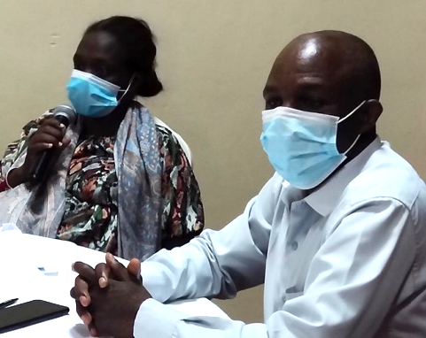
“I am now able to understand the difference between inclusive and integrational education, and implementation of the rights within the community.

My goal is to connect with other counties and form one powerful community that will bring together and advocate for better rights of indigenous persons with disabilities.

Moreover, my aim is to transfer the information learned to rural areas. I want to see more inclusive education in Kenya next year, and to see how government departments can work on inclusive elections in Kenya. I will use my notes about the CRPD to see how to solve the barriers against marginalized groups on a national level.”
Christine Kandie, Leader and CEO of
Endorois Indigenous Women Empowerment Network

Third day
23 June 2020
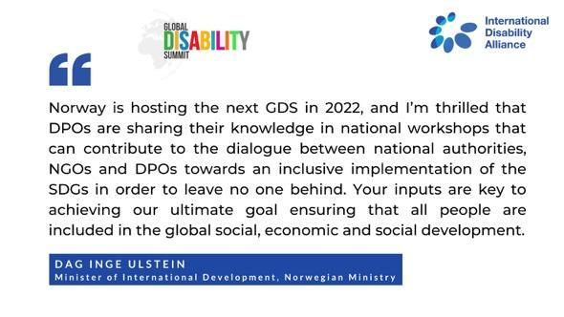
The third and final day of the workshop was dedicated to the Global Disability Summit (GDS) and its national consultations. Facilitators shared about the upcoming GDS 2022, which will take place in Norway. Participants observed two video messages, the first one from IDA’s Executive Director, Vladimir Cuk, and the following message from Norway Minister, Dag Inge Ulstein.
The messages mainly highlighted the importance of inclusive development for all, how the GDS would bring all people with disabilities together, and to take advantage of the GDS consultations to propose the changes they want to see implemented. After this, the group had a discussion on the commitments made about Kenya, and worked on the progress of its implementation.

Recommendations
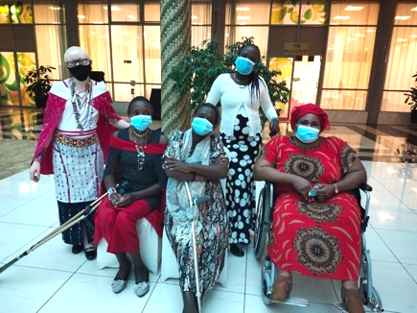
The participants were divided into 10 groups and discussed what is the status of the implementation, if it included indigenous persons with disabilities, and what would be their suggestions. Main commitments covered were related to financial assistance, policies, education, and women’s rights. Some of the recommendations based on the group discussion are:
- Financial cooperation - programs are poorly designed and the budget is not distributed in an inclusive way. A more inclusive system should be designed and data on persons with disabilities and indigenous groups should be mapped out yearly and updated.

- Policies - mainly implemented on the national level and the counties. There is a lack of involvement of indigenous persons with disabilities in critical discussions. Indigenous persons with disabilities should be meaningfully included in the decision-making processes.

- Education and health - indigenous people with disabilities should have the same rights for education and health as others. Indigenous organizations of persons with disabilities can also be an asset to educate teachers and support people on how to work inclusively, as the educational system should be inclusive.

- Reasonable accommodation - It should be provided for the ones requiring it.

- Better rights for women with disabilities - Equality between men and women should be recognized and guaranteed. Women with disabilities should also be respected and recognized as leaders and be given opportunities to make their own choices and decisions. In some communities, women with disabilities do not have rights to inheritance, to have a child or constitute family, among others.
Commitments onwards the GDS 2022
Participants shared the key commitments they want to see taken onwards in the GDS 2022, as follows:
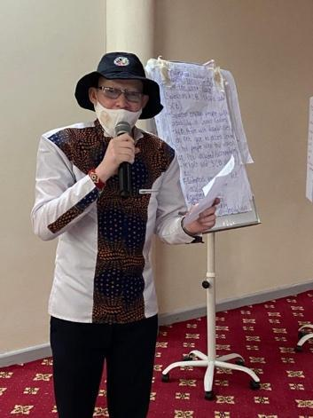
- Implementation of disability bureau of rights,
- Formal recognition of indigenous persons with disabilities,
- Services to be free from taxes (for instance, schools, assistive devices and health services),
- Right to education for everyone, education to be inclusive and have accessibility to materials and schools,
- Persons with disabilities and their representative organizations should be consulted and included in all decision-making processes concerning them, including leadership and public policies,
- More awareness and respect by communities,
- Economic empowerment,
- Enhance job placement for people with disabilities, especially indigenous people with disabilities.

For further information, contact rgalarza@ida-secretariat.org.

